Project: Waste Segregation and Plastic Reduction

Week 1-Project Launch

Introductions
Waste segregation means separating waste into different categories such as biodegradable, recyclable, and non-recyclable waste. Proper waste segregation helps reduce pollution, saves natural resources, and keeps our surroundings clean.
Plastic pollution is one of the biggest environmental problems today. Single-use plastics like plastic bags, bottles, cups, and straws harm animals, rivers, and oceans. Reducing plastic use helps protect the environment.
This project is based on the United Nations Sustainable Development Goals (SDGs).

SDG 12 – Responsible Consumption and Production
- Reduce waste generation.
- Encourage recycling and reuse.
- Use resources wisely.
- Avoid single-use plastics.

SDG 14 – Life Below Water
- Protect oceans, rivers, and marine life.
- Prevent plastic waste from entering water bodies.
- Promote clean water and healthy aquatic ecosystems.

Project Goals
- Create awareness about waste segregation.
- Reduce the use of single-use plastics in school.
- Install separate dustbins for different types of waste.
- Encourage students to recycle and reuse materials.
- Keep the school campus clean.
Student Teams
Team | Responsibility
  Awareness Team
  Conduct awareness campaigns
Survey Team | Collect data on waste generation
Bin Management Team | Check waste segregation bins
Monitoring Team | Observe and report daily activities

Expected Outcome
- Cleaner school campus.
- Reduced plastic waste.
- Students learn proper waste segregation.
- Increased environmental awareness.

Conclusion
This project will help students develop good environmental habits. By reducing plastic use and properly segregating waste, the school can contribute to a cleaner environment.
Week 2 – Waste Audit and Assessment

Introduction
A waste audit is the process of collecting and analyzing the types and amounts of waste produced in a particular area. It helps us understand how much waste is generated every day and how it can be reduced through proper segregation and recycling.
The purpose of this audit is to identify the major sources of waste in our school and encourage responsible waste management.

Waste Audit Method
The waste audit was conducted by observing different areas of the school during the school day.
Areas Surveyed:
- Classrooms
- School Canteen
- Playground
- Staff Room
- Garden
- Corridors
The waste collected was divided into three categories:
- Biodegradable Waste
- Recyclable Waste
- Non-Recyclable Waste

Types of Waste Found
 | Examples
  Type of Waste
Biodegradable | Food waste, fruit peels, leaves, paper tissues
Recyclable | Paper, cardboard, plastic bottles
Non-Recyclable | Chip packets, plastic wrappers, thermocol, disposable cups

Estimated Quantity of Waste (One Day)
Waste Type | Approximate Quantity
Biodegradable | 2.5 kg
Recyclable | 1.5 kg
Non-Recyclable | 1 kg

Student and Staff Survey
A survey was conducted among 30 students and 5 teachers.

Survey Questions
- Do you use reusable water bottles?
- Do you throw waste in the correct dustbin?
- Do you know about waste segregation?
- How often do you use single-use plastic?
- Do you support reducing plastic use in school?

Survey Results
Question | Yes | No
Use reusable water bottle | 27 | 08
Know about waste segregation | 22 | 13
Use correct dustbin | 30 | 05
Use single-use plastic regularly | 00 | 29
Support plastic reduction | 34 | 01
Observations
- Food waste is the largest biodegradable waste.
- Plastic wrappers and disposable bottles are common.
- Many students know about waste segregation but do not always follow it.
- More awareness and proper dustbins are needed.

Recommendations
1. Install colour-coded dustbins (green, blue, and black) in all classrooms and common areas.
2. Reduce the use of single-use plastic in the school canteen.
3. Encourage students to carry reusable water bottles, lunch boxes, and cloth bags.
4. Conduct monthly awareness campaigns on waste segregation and recycling.
5. Put up posters and slogans near dustbins to remind students to dispose of waste correctly.
6. Start a compost pit for biodegradable waste such as food scraps and dry leaves.

7. Collect recyclable materials like paper, plastic bottles, and metal cans separately and send them for recycling.
8. Organize cleanliness drives every month involving students and teachers.
9. Form an Eco Club to monitor waste management and promote environmental activities.
10. Reward classes that maintain the cleanest classroom and follow proper waste segregation.

Conclusion
The waste audit showed that our school generates different types of waste every day. Most of the waste can be recycled or composted if it is properly segregated. The survey also revealed that students are aware of waste management but need to improve their daily habits. By following proper waste segregation, we can reduce pollution and keep our school clean and eco-friendly.

Week 3 – Implementation of Waste Segregation and Plastic Reduction Measures
Introduction
After completing the waste audit, our school started implementing waste segregation and plastic reduction measures. Separate dustbins were placed for different types of waste, and students were encouraged to reduce the use of single-use plastics. These activities promote cleanliness, recycling, and environmental responsibility while supporting sustainable practices and creating a cleaner, greener school campus.

Objectives
1. To implement proper waste segregation in the school.
2. To reduce the use of single-use plastics.
3. To encourage recycling and composting.
4. To develop environmental responsibility among students.
Activities Conducted

1. Installation of Colour-Coded Dustbins
Three types of dustbins were placed in different areas of the school.
Dustbin Colour | Waste Type
Green | Biodegradable Waste
Blue | Recyclable Waste
Black | Non-Recyclable Waste

2. Plastic Reduction Campaign
Students were encouraged to:
- Carry reusable water bottles.
- Use cloth bags instead of plastic bags.
- Avoid plastic straws and disposable cups.
- Bring reusable lunch boxes.

3. Awareness Programme
An awareness programme was organised where students learned:
- Importance of waste segregation.
- Harmful effects of plastic pollution.
- Benefits of recycling and composting.
4. Composting
Composting is the process of converting biodegradable waste such as food scraps, fruit peels, and dry leaves into natural manure. In our school, biodegradable waste is collected separately and placed in a compost pit. Over time, it decomposes and forms nutrient-rich compost, which can be used in the school garden. Composting reduces waste, improves soil fertility, and helps keep the environment clean.
5. Recycling Collection
Recycling collection involves separating recyclable materials such as paper, cardboard, plastic bottles, and metal cans from other waste. These materials are collected in separate bins and sent to recycling centre for processing. Recycling helps conserve natural resources, reduces the amount of waste sent to landfills, saves energy, and protects the environment from pollution.

Observations
- Students started using the correct dustbins.
- Plastic waste in classrooms decreased.
- The school campus became cleaner.
- More students began carrying reusable bottles.
- Awareness about waste segregation increased.

Benefits of the Project
- Reduced plastic pollution.
- Cleaner classrooms and playground.
- Increased recycling.
- Better environmental awareness.
- Protection of natural resources.

Recommendations
- Continue regular awareness programmes.
- Check dustbins every day.
- Organise monthly cleanliness drives.
- Reward students who follow eco-friendly practices.
- Reduce plastic use during school events.

Conclusion
The implementation of waste segregation and plastic reduction measures helped improve cleanliness and environmental awareness in our school. Students actively participated by using separate dustbins and reducing plastic use. These simple actions encouraged responsible waste management and supported sustainable living. Continuing these practices will help create a cleaner, greener, and healthier school for everyone.

Week 4 – Planning the Segregation System
Introduction
After creating awareness about waste segregation, the next step is to plan an effective waste segregation system in the school. A well-planned system helps students dispose of waste correctly and keeps the campus clean. This plan includes installing colour-coded dustbins, placing them in suitable locations, using clear labels, and forming student monitoring teams to ensure proper waste management.
Objectives
1. To introduce a proper three-bin waste segregation system.
2. To reduce waste mixing and improve recycling.
3. To maintain cleanliness throughout the school.
4. To encourage every student to participate in waste management.
Three-Bin Waste Segregation System
Bin Color | Waste Type | Examples
Green | Biodegradable Waste | Food waste, fruit peels, leaves
Blue |  | Paper, cardboard, plastic bottles, metal cans
  Recyclable Waste
Black | Non-Recyclable Waste | Chip packets, plastic wrappers, thermocol

Placement of Dustbins
The dustbins should be placed at:
- Every classroom
- School canteen
- Playground
- School entrance
- Corridors
- Garden
- Staff room
Student Monitoring Teams
A student monitoring team can be formed to ensure proper waste segregation throughout the school. Team members will check whether waste is being placed in the correct bins, remind students to follow the rules, and report any problems to teachers. Their regular monitoring will help maintain cleanliness and encourage responsible waste management habits among all students.

Benefits of the Segregation System
- Keeps the school clean and hygienic.
- Makes recycling easier.
- Reduces plastic pollution.
- Prevents mixing of different types of waste.
- Encourages responsible environmental behaviour.

Recommendations
- Place dustbins in every important location.
- Replace damaged bins immediately.
- Conduct weekly inspections.
- Organise awareness programmes regularly.
- Encourage every student to follow the three-bin system.
Conclusion
A well-planned waste segregation system is essential for maintaining a clean and healthy school environment. Proper placement of colour-coded dustbins and active participation from students make waste management more effective. By following the three-bin system every day, our school can reduce pollution, increase recycling, and promote sustainable habits that protect the environment.

Week 5 – Awareness Campaign
Introduction
An awareness campaign is an effective way to educate students about proper waste management and plastic reduction. By organizing assemblies, displaying posters, and conducting classroom talks, students can learn the importance of waste segregation and sustainable living. These activities encourage everyone to adopt eco-friendly habits and work together to keep the school clean and protect the environment.

Objectives
- To create awareness about waste segregation.
- To reduce the use of single-use plastics.
- To encourage students to recycle and reuse materials.
- To develop responsible environmental habits.
- To involve the entire school in maintaining cleanliness.
Activities Conducted
1. Morning Assembly
A special morning assembly was organized to spread awareness about waste segregation and plastic reduction. Students delivered speeches, shared environmental facts, and took a pledge to keep the school clean. Teachers encouraged everyone to use reusable items and follow proper waste disposal practices. The assembly inspired students to become responsible citizens and protect the environment.

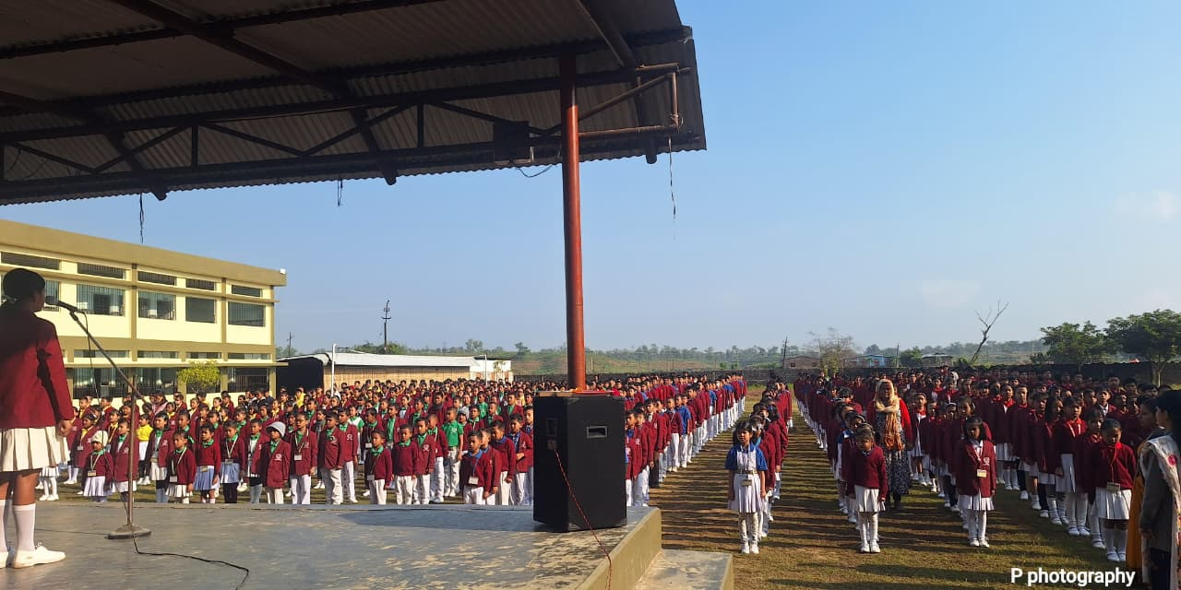
2. Poster Display
Students prepared colorful posters with messages about reducing plastic waste and keeping the environment clean. These posters were displayed in classrooms, corridors, and the school entrance to spread awareness. The attractive designs and slogans encouraged students to practise waste segregation and develop environmentally responsible habits.
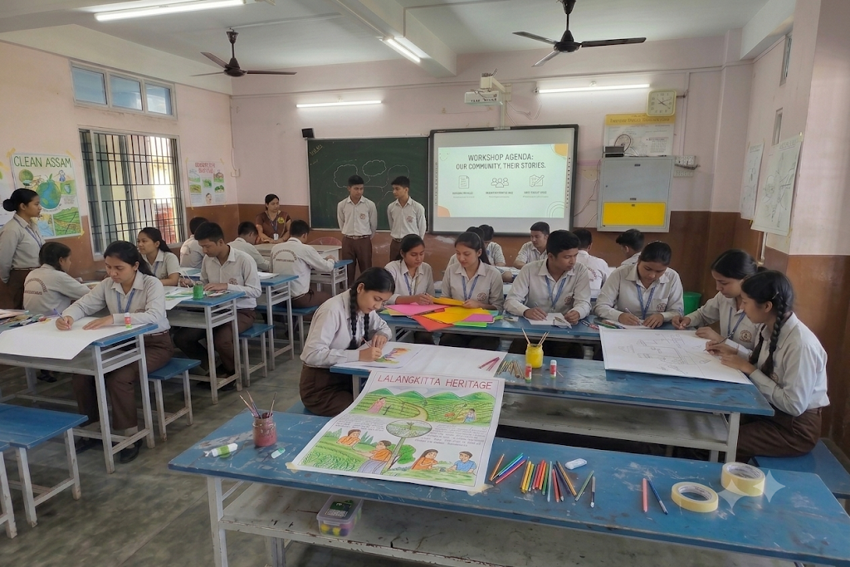

3. Classroom Talk
Teachers conducted classroom discussions on the importance of proper waste disposal and reducing plastic use. Students shared ideas on how they could protect the environment in their daily lives. These interactive sessions helped everyone understand that small actions, such as using reusable items and recycling, can make a big difference.
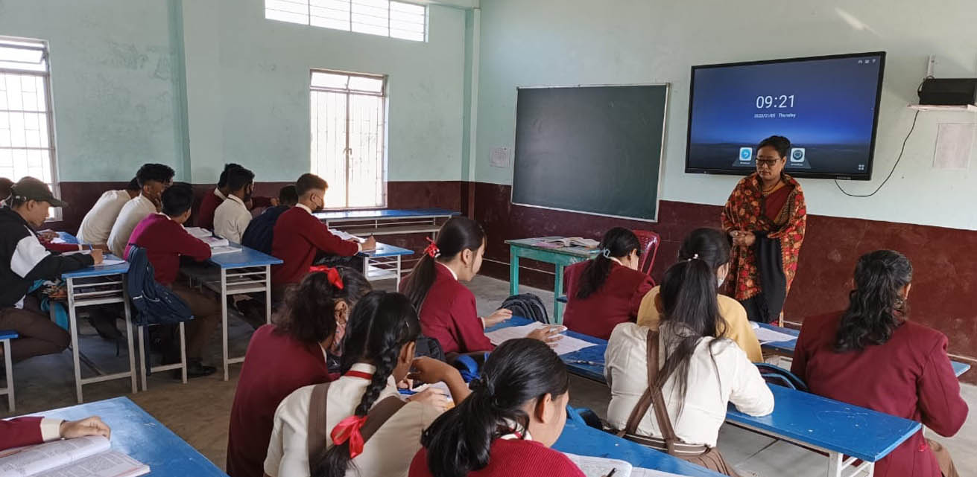

Benefits of the Awareness Campaign
- Increased awareness about waste segregation.
- Reduced use of single-use plastics.
- Cleaner school environment.
- Improved recycling habits.
- Greater participation by students and teachers.

Recommendations
- Conduct awareness programmes every month.
- Display environmental posters permanently.
- Organise quiz and drawing competitions on environmental topics.
- Encourage students to carry reusable bottles and lunch boxes.
- Continue regular cleanliness drives.

Conclusion (50–70 words)
The awareness campaign helped students understand the importance of waste segregation and reducing plastic pollution. Activities such as assemblies, posters, classroom talks, and cleanliness drives encouraged everyone to adopt eco-friendly habits. By working together, students and teachers can maintain a cleaner school and contribute to a healthier and more sustainable environment.

Week 6 – Implementation Phase
Introduction
The implementation phase is the final stage of the project, where the planned waste segregation system is put into daily practice. Colour-coded dustbins are installed in classrooms and common areas, and students are encouraged to dispose of waste correctly. This phase helps develop responsible habits, improve cleanliness, and ensure effective waste management throughout the school.

Objectives
- To implement the three-bin waste segregation system.
- To encourage daily waste segregation.
- To reduce plastic waste in the school.
- To monitor students' participation.
- To maintain a clean and healthy school environment.
Activities Conducted

1. Installation of Segregation Bins
Three colour-coded dustbins were placed in classrooms, corridors, the canteen, and other common areas. Green bins were used for biodegradable waste, blue bins for recyclable waste, and black bins for non-recyclable waste. Clear labels were attached to each bin so that students could easily identify the correct bin for different types of waste.

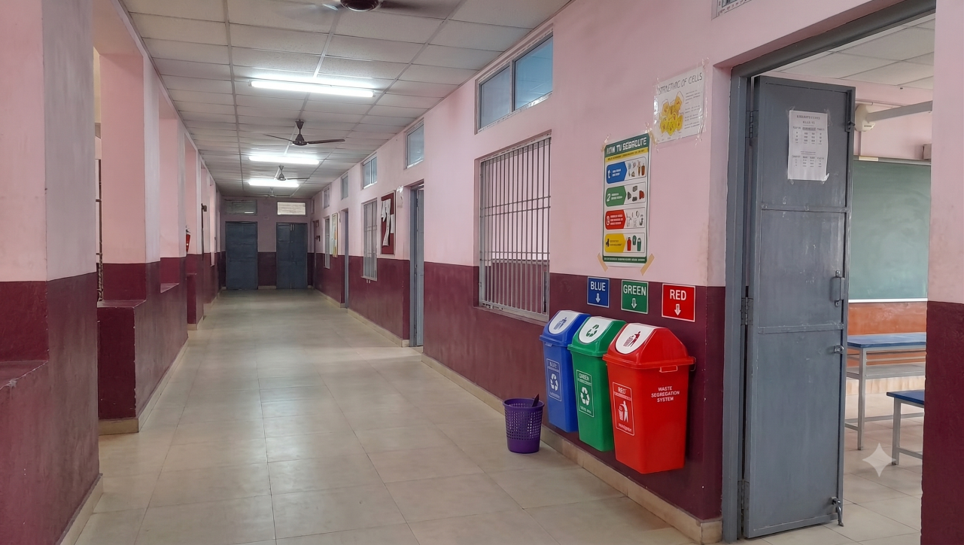
2. Daily Waste Segregation
Students were instructed to separate biodegradable, recyclable, and non-recyclable waste before disposing of it. Teachers guided students on the correct use of each dustbin during school hours. This daily practice helped reduce mixed waste, improved recycling, and encouraged students to develop environmentally friendly habits.
3. Student Monitoring Team
A student monitoring team was formed to supervise the waste segregation process. Team members checked whether waste was being disposed of correctly and reminded students to follow the segregation rules. They also reported any issues to teachers and encouraged everyone to participate actively in keeping the school clean.

4. Daily Record of Waste
The monitoring team maintained a daily record of waste segregation and observed whether students were using the correct bins. They noted the amount of biodegradable, recyclable, and non-recyclable waste collected each day. These records helped evaluate the effectiveness of the waste management system and identify areas for improvement.
Sample Daily Waste Record
Waste Type | Approximate Quantity
Biodegradable | 2.5 kg
Recyclable | 1.5 kg
Non-Recyclable | 1.0 kg
Total | 5 kg

Observations
- Students used the correct dustbins regularly.
- Plastic waste was reduced in classrooms.
- The school campus became cleaner.
- Recycling practices improved.
- Students became more responsible towards the environment.

. Benefits
- Improved cleanliness in the school.
- Reduced plastic pollution.
- Increased recycling.
- Better waste management.
- Developed environmental responsibility among students.

Recommendations
- Continue daily waste segregation throughout the year.
- Conduct regular inspections of dustbins.
- Replace damaged or overflowing bins promptly.
- Organise awareness programmes every month.
- Encourage every student to follow eco-friendly habits.
Conclusion
The implementation phase successfully introduced proper waste segregation practices in the school. Students actively used the colour-coded dustbins and followed the waste management rules. Regular monitoring and teamwork improved cleanliness and reduced plastic waste. By continuing these practices, our school can maintain a healthy environment and contribute to a cleaner and more sustainable future.

Week 7 – Plastic Reduction Drive
Plastic pollution is one of the biggest environmental problems today. To reduce its harmful effects, our school organised a "No Single-Use Plastic Week." Students and teachers were encouraged to avoid disposable plastic items and use eco-friendly alternatives such as reusable bottles, lunch boxes, and cloth bags. This initiative promoted responsible habits and supported environmental conservation.

Objectives
- To reduce the use of single-use plastics in school.
- To encourage the use of reusable and eco-friendly products.
- To spread awareness about plastic pollution.
- To develop responsible environmental habits among students.
- To support sustainable living practices.

Activities Conducted

1. No Single-Use Plastic Week
The school observed "No Single-Use Plastic Week" to encourage students and staff to avoid plastic bags, disposable cups, plastic straws, and plastic bottles. Everyone was motivated to use environmentally friendly alternatives. The campaign helped students understand that reducing plastic waste is an important step towards protecting nature.

2. Use of Reusable Water Bottles
Students were encouraged to bring reusable stainless steel or reusable plastic water bottles instead of buying disposable plastic bottles. This simple habit reduced plastic waste and promoted responsible consumption. Teachers explained how using the same bottle every day helps protect the environment and saves resources.

3. Bringing Reusable Lunch Boxes
Students were advised to carry reusable lunch boxes instead of using plastic wrapping or disposable food containers. This practice reduced plastic waste generated during lunch breaks and encouraged environmentally friendly habits. It also helped students understand the importance of reducing unnecessary plastic in their daily lives.

4. Promoting Cloth Bags
Students and teachers were encouraged to use cloth or jute bags instead of plastic carry bags. Cloth bags are reusable, durable, and environmentally friendly. Awareness was created about how replacing plastic bags with cloth bags can significantly reduce plastic pollution and protect wildlife and natural ecosystems.

5. Eco-Friendly Alternatives
Students learned about eco-friendly alternatives such as paper bags, bamboo products, reusable containers, steel cutlery, and cloth shopping bags. These products can replace single-use plastics and help reduce environmental pollution. Adopting sustainable alternatives supports a cleaner environment and encourages responsible consumption.

Observations
- Most students brought reusable water bottles.
- Plastic bag usage decreased during the campaign.
- More students used reusable lunch boxes.
- Awareness about plastic pollution increased.
- The school campus became cleaner.

Benefits
- Reduced plastic waste.
- Cleaner school environment.
- Increased awareness about sustainability.
- Encouraged eco-friendly habits.
- Protected the environment from plastic pollution.

Recommendations
- Continue the "No Single-Use Plastic Week" every year.
- Ban single-use plastic during school events.
- Encourage students to carry reusable bottles and lunch boxes daily.
- Promote cloth bags instead of plastic bags.
- Conduct regular awareness campaigns on plastic reduction.

Conclusion
The Plastic Reduction Drive encouraged students and teachers to replace single-use plastics with reusable alternatives. The campaign helped reduce plastic waste, increased environmental awareness, and promoted responsible habits. By continuing these eco-friendly practices, our school can contribute to a cleaner environment and inspire everyone to protect nature for future generations.

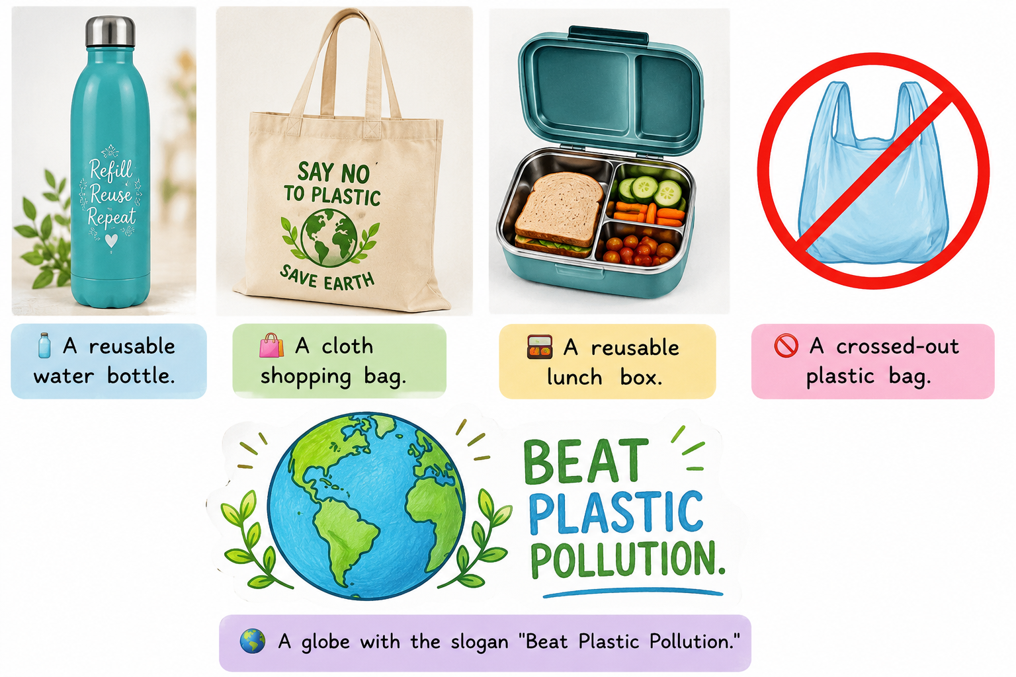

Week 8 – Community Engagement

Introduction
Community engagement is an important step in creating awareness about environmental protection. In this week, our school organised an interactive session with an environmental expert to educate students about plastic waste management and recycling. The programme encouraged students to ask questions, share ideas, and learn practical ways to reduce plastic pollution in their daily lives.

Objectives
- To increase awareness about plastic waste management.
- To understand the importance of recycling.
- To encourage students to adopt eco-friendly habits.
- To involve the community in environmental conservation.
- To inspire students to become responsible citizens.

Activities Conducted

1. Expert Talk
An environmental expert was invited to the school to explain the harmful effects of plastic pollution and the importance of waste segregation. The expert discussed different methods of recycling and encouraged students to reduce the use of single-use plastics. The session motivated everyone to take responsibility for protecting the environment.

2. Interactive Question and Answer Session
Students actively participated by asking questions about waste management, recycling, and environmental conservation. The expert answered each question with practical examples and suggested simple ways to reduce plastic waste at home and in school. This interactive session improved students' understanding and encouraged them to follow eco-friendly practices.

3. Group Discussion
Students formed small groups to discuss ways to reduce plastic pollution in the school and their neighbourhood. Each group shared creative ideas such as using cloth bags, carrying reusable bottles, and organising cleanliness drives. The discussion helped students develop teamwork and problem-solving skills while promoting environmental responsibility.

4. Demonstration on Recycling
The environmental expert demonstrated how recyclable materials such as paper, plastic bottles, and metal cans can be collected and processed into useful products. Students learned the importance of separating recyclable waste and understood how recycling helps conserve natural resources, reduce pollution, and protect the environment.

5. Pledge for a Plastic-Free Future
At the end of the programme, all students took a pledge to reduce the use of single-use plastics and practise proper waste segregation. They promised to use reusable bottles, cloth bags, and lunch boxes whenever possible. The pledge encouraged everyone to work together for a cleaner and healthier environment.

Sample Questions Asked
- Why is plastic harmful to the environment?
- What is the importance of waste segregation?
- How can plastic be recycled?
- What are some alternatives to single-use plastics?
- How can students help reduce plastic pollution?
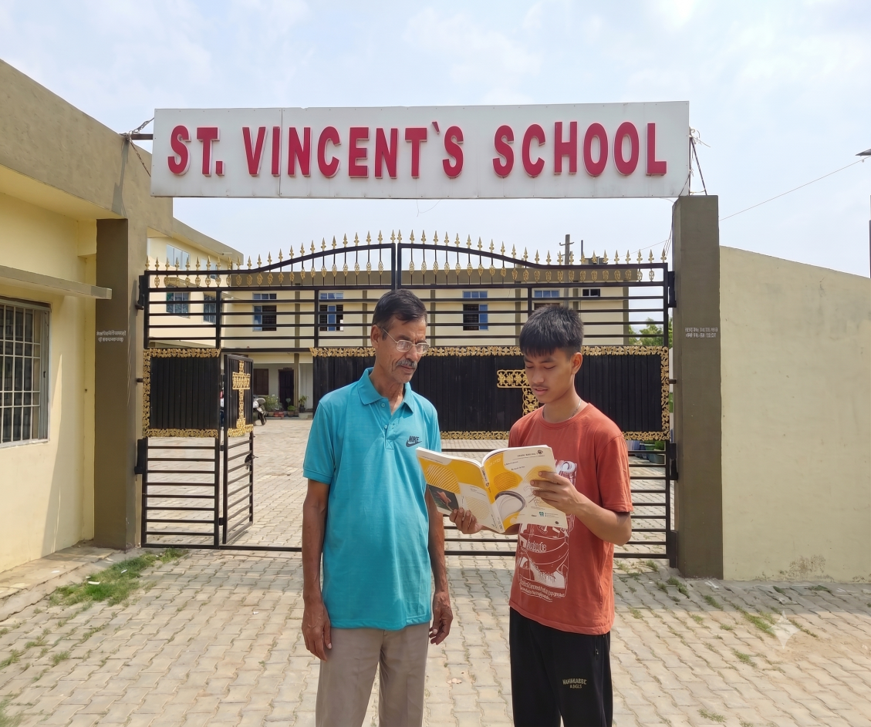

Observations
- Students showed great interest in the session.
- Many students asked meaningful questions.
- Awareness about recycling increased.
- Students promised to reduce plastic use.
- Community participation strengthened the project.

Benefits
- Improved knowledge about recycling.
- Encouraged responsible environmental behaviour.
- Increased community participation.
- Promoted teamwork and communication.
- Inspired students to protect nature.

Recommendations
- Invite environmental experts every year.
- Organise more interactive workshops.
- Encourage parents to participate in awareness programmes.
- Conduct community cleanliness drives.
- Continue promoting plastic-free habits in school.

Conclusion
The community engagement programme successfully increased awareness about plastic waste management and recycling. Students actively participated in discussions, asked thoughtful questions, and learned practical ways to protect the environment. The expert's guidance inspired everyone to reduce plastic use and practise responsible waste management, helping create a cleaner, greener, and more sustainable future.

Week 9 – Creative Recycling Workshop

Introduction
The Creative Recycling Workshop encouraged students to reuse waste materials by turning them into useful and decorative items. Instead of throwing away plastic bottles, cans, and old newspapers, students learned creative ways to recycle them. This activity reduced waste, promoted creativity, and inspired everyone to protect the environment through sustainable practices.

Objectives
- To promote the reuse of waste materials.
- To encourage creativity through recycling.
- To reduce plastic and other solid waste.
- To teach students the importance of upcycling.
- To develop eco-friendly habits.

Activities Conducted

1. Eco-Brick
Students learned how to make eco-bricks by tightly filling clean plastic bottles with non-recyclable plastic waste such as wrappers and plastic packets. These eco-bricks can be used for making benches, garden borders, and other simple structures. This activity helped reduce plastic waste and demonstrated an innovative way to reuse materials.

2. Making Decorative Items
Students used waste materials like old newspapers, cardboard, plastic bottles, and bottle caps to create decorative items such as flower vases, pen stands, photo frames, and wall hangings. This activity encouraged creativity while showing that many discarded items can be transformed into useful and attractive products.

3. Bottle Planters
Old plastic bottles were cleaned, cut, and decorated to make attractive plant pots. Students planted small flowers and herbs in these bottle planters and placed them around the school. This activity promoted gardening, reduced plastic waste, and improved the beauty of the school campus.

4. Best Out of Waste Competition
A "Best Out of Waste" competition was organised where students created useful items from waste materials. They displayed their projects and explained how recycling helps protect the environment. The competition encouraged innovation, teamwork, and awareness about sustainable waste management.

5. Exhibition of Recycled Items
An exhibition was organised to display all the recycled and upcycled items made by the students. Teachers, students, and parents visited the exhibition and appreciated the creative ideas. The display inspired everyone to reuse waste materials instead of throwing them away.

Materials Used
- Plastic bottles
- Newspapers
- Cardboard
- Bottle caps
- Ice cream sticks
- Glue and scissors
- Paint and coloured paper

Observations
- Students showed great creativity.
- Plastic waste was reused effectively.
- Many useful items were created from waste.
- Awareness about recycling increased.
- Students enjoyed learning through practical activities.

Benefits
- Reduced plastic waste.
- Improved creativity and problem-solving skills.
- Encouraged recycling and reuse.
- Beautified the school campus.
- Promoted environmental responsibility.

Recommendations
- Organise recycling workshops every term.
- Display recycled items in classrooms.
- Encourage students to make useful items at home.
- Collect waste materials for future projects.
- Promote the "Reduce, Reuse, Recycle" principle.

Conclusion
The Creative Recycling Workshop showed that waste materials can be transformed into useful and attractive products through imagination and effort. Students enjoyed making eco-bricks, planters, and decorative items while learning the importance of recycling. The workshop promoted creativity, reduced waste, and encouraged everyone to adopt sustainable practices for a cleaner and greener environment.

Week 10 – Community Awareness Initiative

Introduction
Creating awareness in the community is an important step towards protecting the environment. During this week, students organised a neighbourhood awareness drive to educate people about waste segregation, plastic reduction, and recycling. Informational leaflets were distributed, and demonstrations were conducted to encourage families to adopt eco-friendly habits and maintain a clean, healthy environment.

Objectives
- To spread awareness about waste segregation in the community.
- To encourage people to reduce the use of single-use plastics.
- To promote recycling and composting.
- To involve local residents in environmental protection.
- To inspire responsible waste management practices.

Activities Conducted

1. Community Awareness Drive
Students visited nearby homes and public places to spread awareness about proper waste management. They explained the importance of using separate bins for biodegradable, recyclable, and non-recyclable waste. Community members were encouraged to keep their surroundings clean and reduce plastic pollution by following simple eco-friendly practices.

2. Distribution of Informational Leaflets
Students distributed informative leaflets containing useful tips on waste segregation, recycling, composting, and reducing plastic waste. The leaflets explained the benefits of protecting the environment in simple language. This activity helped families understand how small changes in daily habits can make a positive impact on nature.

3. Demonstration of Waste Segregation
Students demonstrated the correct method of separating biodegradable, recyclable, and non-recyclable waste using three colour-coded bins. They explained what type of waste should be placed in each bin and answered questions from community members. The demonstration encouraged people to practise proper waste segregation in their homes.

4. Plastic-Free Awareness Campaign
Students encouraged people to replace single-use plastic bags, bottles, and containers with reusable alternatives such as cloth bags, steel bottles, and reusable lunch boxes. They explained how reducing plastic waste protects wildlife, prevents pollution, and helps create a cleaner environment for future generations.

5. Community Pledge
At the end of the programme, community members took a pledge to reduce plastic use, segregate waste at home, and support recycling. They promised to follow eco-friendly practices and inspire others to care for the environment. The pledge strengthened community participation and encouraged collective responsibility.

Observations
- Many residents showed interest in the awareness programme.
- Families appreciated the waste segregation demonstration.
- More people agreed to reduce plastic use.
- Community participation increased.
- Environmental awareness improved.

Benefits
- Increased awareness among local residents.
- Promoted proper waste segregation.
- Reduced plastic pollution.
- Encouraged recycling and composting.
- Strengthened community responsibility.

Recommendations
- Organise community awareness drives every few months.
- Distribute educational leaflets regularly.
- Install colour-coded dustbins in public places.
- Encourage households to compost biodegradable waste.
- Continue promoting plastic-free lifestyles.

Conclusion
The community awareness initiative successfully educated local residents about waste segregation, recycling, and plastic reduction. Through demonstrations, leaflets, and discussions, students inspired families to adopt eco-friendly habits. The programme showed that when schools and communities work together, they can reduce pollution, protect the environment, and build a cleaner, greener future.

Week 11 – Evaluation and Impact Measurement

Introduction
Evaluation and impact measurement help us understand the success of the waste segregation and plastic reduction project. By comparing the initial waste audit with the final results, we can measure improvements in waste management. Feedback from students and teachers also helps identify the project's achievements and suggests ways to make future environmental activities more effective.

Objectives
- To evaluate the success of the project.
- To compare waste audit results before and after implementation.
- To measure the reduction in plastic usage.
- To collect feedback from students and teachers.
- To identify areas for further improvement.

Activities Conducted

1. Comparison of Waste Audit Data
The waste generated at the beginning of the project was compared with the waste collected after implementing waste segregation. The comparison showed better segregation of waste and a noticeable reduction in plastic waste. Recycling increased, and biodegradable waste was managed more effectively through composting.

2. Measuring Plastic Reduction
The amount of single-use plastic used in the school was observed and compared with the initial survey. Students started using reusable water bottles, cloth bags, and lunch boxes, which significantly reduced plastic waste. The campaign proved that small daily changes can make a positive impact on the environment.

3. Feedback from Students and Teachers
A short feedback survey was conducted among students and teachers. Most participants appreciated the project and agreed that it improved awareness about waste segregation and recycling. Many suggested continuing the programme throughout the year and organising more environmental activities in the future.

4. Analysis of Results
The collected data showed that the project successfully improved waste management practices in the school. Students became more responsible in using colour-coded bins, and plastic waste decreased. Regular awareness campaigns and monitoring played an important role in achieving these positive results.

Comparison Table
Category | Before Project | After Project
Total Waste | 5 kg/day | 4 kg/day
Plastic Waste | 1.5 kg/day | 0.8 kg/day
Recyclable Waste | 1 kg/day | 1.5 kg/day
Students Following Segregation | 40% | 90%

Observations
- Plastic waste reduced significantly.
- More students used reusable bottles and lunch boxes.
- Waste segregation improved.
- The school campus became cleaner.
- Environmental awareness increased among students.

Benefits
- Reduced plastic pollution.
- Better recycling practices.
- Improved cleanliness.
- Increased participation of students and teachers.
- Stronger environmental responsibility.

Recommendations
- Continue waste audits every month.
- Organise regular awareness campaigns.
- Increase the number of recycling bins.
- Encourage every student to avoid single-use plastics.
- Continue monitoring the waste segregation system.

Conclusion
The evaluation showed that the project successfully improved waste segregation and reduced plastic usage in the school. Students and teachers actively participated and developed better environmental habits. Comparing the initial and final results confirmed that regular awareness, teamwork, and proper waste management can create a cleaner, greener, and more sustainable school environment.

Week 12 – Presentation and Sustainability Plan

Introduction
The final week of the project focused on presenting the achievements of the waste segregation and plastic reduction programme. Students shared the project's activities, results, and learning experiences with teachers and classmates. A sustainability plan was also prepared to ensure that waste segregation and eco-friendly practices continue in the school even after the project is completed.

Objectives
- To present the outcomes of the project.
- To share the knowledge gained during the project.
- To prepare a sustainability plan for the future.
- To encourage continuous waste segregation and plastic reduction.
- To inspire students to adopt environmentally responsible habits.

Activities Conducted

1. Project Presentation
Students presented their project through charts, posters, photographs, and reports. They explained the objectives, activities, and outcomes of the twelve-week programme. The presentation highlighted improvements in waste segregation, recycling, composting, and plastic reduction. Teachers and classmates appreciated the efforts and encouraged students to continue these practices.

2. Display of Project Work
An exhibition was organised to display posters, eco-bricks, bottle planters, recycled crafts, survey reports, and photographs. Students explained how these activities helped reduce waste and protect the environment. The exhibition inspired visitors to follow eco-friendly practices and understand the importance of responsible waste management.

3. Sustainability Plan
A sustainability plan was prepared to continue waste segregation and plastic reduction throughout the year. Students suggested maintaining colour-coded dustbins, conducting monthly waste audits, organising awareness campaigns, and encouraging the use of reusable bottles, lunch boxes, and cloth bags. These measures will help keep the school clean and environmentally friendly.

4. Future Commitments
Students and teachers agreed to continue practising waste segregation and reducing the use of single-use plastics. The Eco Club will monitor waste management activities and organise regular cleanliness drives and awareness programmes. These commitments will ensure that the positive impact of the project continues in the future.

Sustainability Plan
- Continue using the three-bin waste segregation system.
- Conduct monthly waste audits.
- Organise awareness campaigns every month.
- Encourage reusable bottles, lunch boxes, and cloth bags.
- Maintain a compost pit for biodegradable waste.
- Send recyclable materials to authorised recycling centres.
- Form an Eco Club to monitor environmental activities.
- Celebrate World Environment Day with special programmes.

Project Achievements
- Successfully introduced waste segregation in the school.
- Reduced the use of single-use plastics.
- Increased recycling and composting.
- Improved cleanliness across the campus.
- Increased environmental awareness among students.
- Encouraged teamwork and responsible behaviour.

Recommendations
- Continue the project every academic year.
- Involve parents and the local community.
- Increase the number of colour-coded dustbins.
- Reward students who actively follow eco-friendly practices.
- Conduct regular workshops on recycling and sustainability.

Conclusion
The presentation and sustainability plan marked the successful completion of the project. Students proudly shared their achievements and committed to continuing waste segregation and plastic reduction in the future. By following the sustainability plan, our school can maintain a cleaner environment, reduce pollution, and inspire everyone to adopt responsible and eco-friendly habits.

