TOPIC :COMMUNITY HEALTH AND OUTREACH

GOAL OF COMMUNITY HEALTH OUTREACH:
The primary goal of community health and outreach is to bridge the gap between healthcare providers and underserved populations. By bringing vital education, preventive services, and resources directly into neighbourhoods, these initiatives aim to eliminate health disparities, promote health equity, and empower individuals to manage their well-being. To promote health awareness, preventive healthcare practices, and community well- being through- led outreach activities. The project aims to encourage responsible health habits, empathy, and active citizenship while strengthening school- community partnerships in alignment with SDG3 (Good Health and Well – being), SDg4 (Quality Education), and SDG17 (Partnerships for the Goals).
SDG3 stand for Sustainable Development Goal (SDG) 3 aims to ensure healthy lives and promote well-being for all ages. It sets concrete 2030 targets to eradicate major communicable diseases, achieve universal healthcare, and address environmental and lifestyle – related health risks.
Sustainable Development Goal 4 (SDG 4) aims to "ensure inclusive and equitable quality education and promote lifelong learning opportunities for all" by 2030. Key objectives include ensuring free primary and secondary education for all, eliminating gender and wealth disparities, and improving access to vocational training.
Sustainable Development Goal 17 (SDG17 or Global Goal 17) advances "partnerships for the goals." As one of the 17 H established by the United Nations in 2015, SDG17 aims to "strengthen the means of implementation and revitalize the global partnership for sustainable development."
SDG17 refers to the need for the no hegemonic and fair cross sector and cross country collaborations in pursuit of all the goals by the year 2030. The framework calls on international stakeholders to coordinate their efforts toward accomplishing the SDGs.
Sustainable Development Goal 17
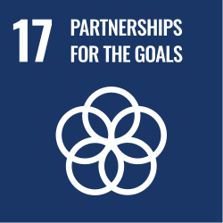
Mission statement | "Strengthen the means of implementation and revitalize the global partnership for sustainable development"

WEEK1- PROJECT LAUNCH

Introduction to Community Health Outreach:
Community Health Outreach can be used to communicate health initiatives, increase participation in key initiatives, and ensure the public knows where they can locate health services.
Health and Human Services agencies have learned that a community's health goes beyond just access to healthcare services. Understanding the interplay of behaviour, physical and social environments, biological and genetic factors, and access to health systems helps health and human services agencies devise initiatives that ultimately increase the well-being of all residents. Increasing public health requires a robust and transparent public education campaign that provides accurate healthcare information, progress on key healthy community initiatives, and guidance needed to access assistance. A key aspect of any healthy community program is a web destination that helps the public locate healthcare providers, review key initiatives, request assistance and volunteer to help. Community Health Outreach is typically implemented by public or private health and human services agencies that want to increase the quality of life for all residents and ensure the public understands where health services can be found in the community.
The Community Health Outreach solution delivers a set of capabilities that help you launch a healthy communities web destination, provide an authoritative inventory of healthcare services, and engage the public in key health initiatives that increase the quality of life for all.
MEANING OF COMMUNITY, HEALTH AND OUTREACH:
Community health outreach refers to the proactive delivery of healthcare resources, education, and services directly to underserved or at-risk populations where they live or gather. It acts as a vital bridge between formal medical systems and local neighbourhoods, aiming to reduce health disparities and promote equity. Understanding the meaning of these three concepts reveals how they work together:
1. Community
A community is a group of people who share common characteristics, such as geographic location, cultural background, interests, or shared challenges. In health contexts, it defines the population that shares specific environmental, social, or medical risks.
2. Health
Health is a state of complete physical, mental, and social well-being, not merely the absence of disease. On a macro scale, Community Health focuses on the overall well-being of a specific geographic population. It looks at how socioeconomic factors (like housing, employment, and sanitation), environment, and daily choices collectively affect a neighbourhood.
3. Outreach
Outreach involves stepping outside traditional medical facilities—such as hospitals or clinics—to engage with individuals directly. It is a strategic effort to build relationships, increase awareness, and provide practical assistance to those who face barriers (such as lack of transportation or financial constraints) to accessing care.
When combined, Community Health Outreach represents the mobile and targeted efforts (like free neighbourhood health screenings, mobile vaccination drives, or localized educational campaigns) that bring wellness services directly to vulnerable people. These programs rely on trained community health workers to establish trust and ensure residents receive necessary medical services, counselling, and preventative care.

WEEK 2-COMMUNITY HEALTH ASSESMENT:
Community Health Assessments (CHAs) are systematic processes for identifying key health needs, prioritizing issues, and allocating resources. Addressing critical determinants like nutrition, hygiene, mental health, lifestyle diseases, and access to care requires an evidence-based approach that targets inequalities at both the individual and population levels. A structured breakdown of these core community health areas highlights specific issues, indicators, and recommended interventions: 1. Nutrition
- Key Issues: Widespread under nutrition (stunting/wasting) in children, micronutrient deficiencies, and over nutrition (obesity) are common.]
- Assessment Indicators: Body Mass Index (BMI) distribution, dietary diversity scores, and prevalence of anaemia.
- Actionable Interventions: Promoting exclusive breastfeeding, supplementing critical micronutrients, and implementing school-based healthy eating initiatives.

- 2. Hygiene & Sanitation
- Key Issues: Suboptimal drinking water practices, lack of proper toilet facilities, and poor personal hygiene contribute to the burden of communicable and waterborne diseases. Assessment Indicators: Access to improved sanitation facilities, frequency of hand washing, and rates of diarrheal diseases.
- Actionable Interventions: Expanding public hand washing infrastructure, promoting community-led total sanitation programs, and ensuring safe drinking water access.

3. Mental Health
- Key Issues: High levels of chronic stress, anxiety, and depression that are frequently compounded by socio-economic challenges, lack of social support, and isolation.
- Assessment Indicators: Depression/Anxiety screening surveys, hospitalization rates for psychiatric conditions, and self-reported mental well-being. Actionable Interventions: Integrating basic mental health services into primary care, establishing community support networks, and implementing stress management programs.

4. Lifestyle Diseases
- Key Issues: A dramatic rise in non-communicable diseases (NCDs) like type 2 diabetes, hypertension, and cardiovascular diseases, primarily driven by physical inactivity, poor diet, and stress.
- Assessment Indicators: Blood pressure and blood glucose levels, physical activity levels, and smoking/tobacco consumption rates.
- Actionable Interventions: Widespread public awareness campaigns, tobacco and alcohol control policies, and initiatives encouraging routine physical activity.

5. Access to Healthcare
- Key Issues: Significant barriers include financial constraints (lack of medical insurance), geographical distance to specialists, transportation challenges, and a lack of culturally relevant care.
- Assessment Indicators: Geographic distribution of healthcare facilities, utilization rates of primary care, and preventable hospital readmission rates.
- Actionable Interventions: Expanding telehealth capabilities, deploying mobile health clinics to remote or underserved regions, eland training community health workers.

WEEK 3-RESEARCH AND PLANNING TO COMMUNITY HEALTH OUTREACH:
Researching and planning for common health challenges requires identifying the specific disease burden, social determinants, and resource gaps impacting a population. Effective strategies combine evidence-based policymaking, proactive surveillance, and community-level interventions tailored to local healthcare systems.
1. Identify Priority Health Challenges
When planning, public health initiatives often focus on universal categories of illness and risk factors:
- Non-Communicable Diseases (NCDs): Conditions like cardiovascular disease, cancer, and diabetes. They are primarily driven by lifestyle determinants such as poor nutrition, physical inactivity, and substance abuse.
- Infectious Diseases: Threats like malaria, tuberculosis, and respiratory illnesses. Planning requires monitoring antimicrobial resistance (AMR) and ensuring early detection protocols.
- Mental Health Crises: Rising rates of anxiety and depression, which are frequently worsened by poor health systems integration and modern socioeconomic stressors.
- Environmental & Climate :
- Threats: Vulnerabilities arising from air/water pollution and the direct health impacts of extreme weather events.
2. Key Data Collection and Planning Frameworks
To understand the specific health challenges in your area, researchers and planners rely on established methodologies and resources:
- Epidemiological Surveillance: Using prospective studies and retrospective reviews of data to monitor disease outbreaks and map health trends over time
- Social Determinants Analysis: Evaluating the broader conditions that affect health outcomes, including socioeconomic status, gender norms, and the built environment. Global Monitoring: Tracking worldwide priorities via the World Health Organization Health Topics portal.
- National and Local Data: Leveraging localized resources such as the Indian Council of Medical Research (ICMR) to understand regional disease priorities and research policies.
3. Implementing Evidence-Based Interventions
Once health challenges are researched, action plans often centrearound structural and policy shifts:
- System Integration: Addressing fragmented data systems and a lack of interoperability across health networks to improve the coordination of patient care.
- Health Equity and Accessibility: Expanding access to care for remote or marginalized populations by reducing out-of-pocket costs and improving transport infrastructure.
Resource Management: Streamlining the procurement of drugs and medical devices, and allocating trained health workers more efficiently between rural and urban areas.
Health studies span a broad range of topics, including disease prevention, lifestyle behaviours, and healthcare systems. In India, current research heavily emphasizes the rapid rise of lifestyle diseases like diabetes and cardiovascular conditions, which are often exacerbated by sedentary habits and high stress.
Exploring these topics is crucial for creating effective public health interventions. If you're looking for clinical, epidemiological, or molecular health data, reputable organizations continuously publish foundational research:

Common health challenges include non-communicable diseases (NCDs) like cardiovascular disease, diabetes, hypertension, and obesity. In India specifically, widespread air pollution, high rates of respiratory and gastrointestinal infections (like tuberculosis), and growing mental health issues are significant localized concerns.
Navigating these challenges requires understanding their root causes and taking actionable steps to manage your well-being. Below are the details for managing the most widespread health issues:
1. Non-Communicable Diseases (NCDs)
Conditions like hypertension, diabetes, and heart disease are driven by lifestyle factors such as poor diet, physical inactivity, and stress.
- Hypertension & Heart Disease: High blood pressure often has no symptoms but can lead to heart attacks or stroke. Monitor your levels and aim to limit daily salt intake to less than 5g.
- Diabetes: This chronic condition affects how the body processes blood sugar. Preventative measures include maintaining a healthy Body Mass Index (BMI) and regular blood sugar testing.
2. Respiratory & Infectious Diseases
Particularly in urban and heavily populated regions of India, environmental and infectious respiratory issues are major threats. Air Pollution Effects: Thick smog and toxic air worsen conditions like asthma and chronic bronchitis. Wearing protective masks (like N95s) on high-pollution days is strongly advised.
- Tuberculosis (TB) & Pneumonia: These infectious diseases remain highly prevalent. Ensure prompt medical care if you experience a persistent cough or fever, and seek immediate treatment to prevent drug-resistant strains.
3. Mental Health Challenges
Mental health concerns are a growing concern in India, often exacerbated by the fast-paced modern lifestyle.
- Stress & Anxiety: These are incredibly common and can manifest physically (fatigue, headaches). Practices like meditation, reduced caffeine intake, and therapy can significantly improve mental well-being.
- 4. Nutritional Deficiencies
Malnutrition and vitamin deficiencies remain a critical hurdle across various demographics in the region. Anaemia& Vitamin D: Deficiencies in iron and essential vitamins are common. A balanced, nutrient-dense diet and consultation with a healthcare provider can identify needed supplements.
PREVENTIVE MEASURES
Community health outreach delivers essential preventive healthcare directly to vulnerable or underserved populations. It aims to reduce disease burden and improve public health literacy through health education, vaccinations, early-detection screenings, and lifestyle counselling.
Common preventive measures implemented through effective health outreach include:
1. Health Education & Promotion
- Disease Awareness: Campaigns focusing on the risks of communicable and non-communicable diseases (NCDs) like hypertension, diabetes, and cancer.
- Lifestyle Counselling: Guidance on maintaining a nutritious diet, avoiding tobacco/alcohol, and engaging in regular physical activity.
2. Immunization & Vaccination
- Routine Drives: Mobile units and community health workers (CHWs) provide routine childhood immunizations (e.g., MMR, polio, HPV) and seasonal adult vaccines (e.g., influenza, pneumonia) to increase population coverage.
3. Early Detection & Screenings
- Check-up Camps: Free or subsidized camps offering routine blood pressure, blood glucose, and body mass index (BMI) screenings.
- Targeted Screenings: Proactive check-ups for colorectal and cervical cancer (e.g., HPV self-testing kits) to catch diseases early.
4. Environmental & Behavioural Health
- Water & Sanitation: Educational sessions focused on proper waste disposal and improving community sanitation systems to prevent water-borne illnesses.
- Harm Reduction: Providing sterile supplies and safe-sex resources to prevent the spread of infectious diseases.
Key Strategies for Successful Outreach
- Community Health Workers (CHWs): Engaging trusted locals as liaisons bridges the gap between marginalized communities and formal health systems.
- Mobile Health Units: Bringing clinics, diagnostic tools, and treatments directly to urban slums and remote rural areas.

GOVERNMENT HEALTH SCHEMES

India’s government health outreach is anchored by the National Health Mission (NHM) and the Ayushman Bharat initiative. These programs focus on preventative care, free health insurance, and targeted medical assistance for common and critical diseases across the country. The primary health schemes include:
1. AyushmanArogyaMandir (AAM)
Formerly known as Health and Wellness Centres, these community hubs bring primary healthcare closer to homes by offering 12 free services. This includes maternal/child health, free essential drugs, teleconsultation services, and screening for non-communicable diseases like diabetes and hypertension.
2. Ayushman Bharat - PMJAY
The world’s largest government-funded health assurance scheme provides free secondary and tertiary healthcare coverage of ₹5 Lakh per family per year. The scheme includes universal coverage for all senior citizens aged 70 and above, regardless of income. Benefits are redeemable across a nationwide network of empaneled public and private hospitals.
3. National Health Mission (NHM) - The overarching program includes several targeted community outreach scheme.

Mission Indradhanush: A massive vaccination drive targeting pregnant women and children against 12 vaccine-preventable diseases.
- Pradhan MantriSurakshitMatritvaAbhiyan (PMSMA): Provides pregnant women with assured, free antenatal checkups by specialists on the 9th of every month.
- RashtriyaBalSwasthyaKaryakram (RBSK): Focuses on early identification and free management of diseases, developmental delays, and defects in children.
4. Disease-Specific & Financial Support Schemes
- NikshayPoshanYojana: Provides nutritional and financial support for registered tuberculosis (TB) patients throughout their treatment.
- National Programme for Prevention and Control of Non-Communicable Diseases (NPCDCS): Conducts widespread community screenings for hypertension, diabetes, and common cancers. Pradhan MantriBhartiyaJanaushadhiPariyojana (PMBJP): Provides quality generic medicines at significantly discounted prices through dedicated Kendra outlets.

PLAN AWARENESS CAMPAIGNS

A highly effective awareness campaign requires a structured, phased approach that connects your core message to the right community. By integrating behavioural insights, targeted messaging, and on-the-ground support, you can drive actionable change within the community.
Phase 1: Preparation & Audience Mapping
Before launching, establish clear parameters to ensure your activities are impactful and directly address the specific community's needs.
Set Clear Goals: Define measurable objectives, such as the number of people to screen, educational pamphlets distributed, or engagement metrics.
Map the Audience: Identify the exact demographic you need to reach (e.g., school children, rural communities, or the elderly). Leverage Partnerships: Collaborate with local Hh global health days, community leaders, NGOs, and medical professionals to maximize resources and establish trust.
Phase 2: Campaign Development
Craft localized, culturally relevant messaging that resonates deeply with the specific target audience.
- Refine the Message: Keep messaging simple, actionable, and free of confusing medical jargon.
- Determine Channels: Utilize a blend of media, including local Social Media Platform campaigns, radio announcements, and highly visible Outdoor Advertising billboards.
- Design Materials: Use visual, easy-to-understand educational materials tailored to local literacy levels.
Phase 3: Execution of Health Drives & Outreach
Transform awareness into measurable action through direct, community-based H.
Health Camps & Mobile Clinics: Set up temporary physical hubs to provide free health screenings, BMI assessments, and blood pressure checks.
- Interactive Workshops: Host seminars on disease prevention, hygiene practices, and healthy eating habits. Resource Distribution: Hand out essential health-related products, such as nutritional worksheets, illustrated posters, and hygiene kits.
Phase 4: Monitoring, Evaluation & Follow-up
Ensure long-term impact by tracking data and maintaining a connection with the community.
- Track Analytics: Use digital dashboards to measure social media reach and event attendance.
- Collect Feedback: Gather direct community feedback through surveys to adapt and improve future outreach efforts.
- Establish Follow-Up: Create a referral system or provide localized contact information to ensure individuals needing further care receive professional follow-up.

WEEK 4-AWARENESS CAMPAIGN DESIGN:

Designing an effective health outreach campaign requires clear objectives, a hyper-targeted audience, and accessible messaging. A step-by-step framework structures your rollout to drive real-world behaviour change and measurable health outcomes. An Information, Education, and Communication (IEC) campaign uses targeted communication strategies to bridge information gaps, promote positive behaviours, and mobilize communities. Effective design involves conducting a local needs assessment, defining measurable behavioural objectives, and delivering tailored messaging through integrated print, digital, and grassroots channels.
Developing an IEC campaign follows a structured lifecycle to ensure the target audience both understands and acts upon the information:
1. Audience & Needs Analysis
- Demographics: Understand the age, language, literacy level, and cultural norms of your local audience.
- Baseline Knowledge: Determine the community’s current knowledge, attitudes, and practices (KAP) regarding the specific issue to bridge the correct gaps.
2. Strategic Design & Messaging
- Clear Objectives: Set precise goals, such as increasing health service enrolment or reducing environmental waste.
- Tailored Messaging: Craft simple, evidence-based messages that address local myths and provide actionable steps.
- Multi-Channel Approach: Combine visual, auditory, and experiential formats. For local impact, pair printed posters or flyers with community workshops, street theatre, or radio announcements.
- 3. Material Development
IEC materials are designed to be immediate and highly legible. Popular formats include: Print: Posters, brochures, leaflets, and wall paintings.
- Digital: Social media posts, short-form videos, and targeted mobile messaging.
- Interpersonal: Health fairs, seminars, and peer-to-peer discussions.
- 4. Implementation & Reach
- Community Engagement: Mobilize local leaders, schools, and civic groups to build trust and ensure the campaign resonates.
- Accessibility: Ensure information is available in local dialects and formatted for those with limited reading proficiency.
- 5. Monitoring and Evaluation
- Track community engagement and adjust tactics to ensure the campaign is effectively shifting behaviour.
- Slogan & Messaging Framework
- Health: "Your Body is Your Home, Protect It."
- Nutrition: "Eat for Energy, Not Just Comfort."
- Sanitation: "Clean Hands, Clear Path to Health."
- Mental Wellness: "Mind Matters: Breathe, Rest, Reach Out."
- Preventive Care: "Catch it Early, Live Life Fully."

WEEK 5-SCHOOL HEALTH AWARENESS DRIVE:
Building awareness around disease prevention from an early age is one of the most effective ways to protect children’s health. When children understand basic hygiene, nutrition, and early symptoms, they are better equipped to avoid illnesses and respond quickly when something is wrong. In India, where many children still face challenges like unsafe water and limited healthcare access, education becomes a powerful tool for long-term change.
1. Disease prevention: Focusing on disease prevention early in life helps reduce long-term health risks, lowers the chances of school absenteeism, and supports the growth of strong, healthy communities. When children grow up understanding hygiene, nutrition, and when to seek help, they are more likely to lead healthier and m Some of the most common illnesses include diarrhoea, respiratory infections, dengue, malaria, and skin infections. These are largely preventable with proper hygiene, clean water, vaccination, and awareness about prevention of common diseases.

2. Promoting Hygiene Practices: Hand washing, Sanitation, Clean Water

Hand washing with soap at key times, such as after using the bathroom and before eating, is one of the most effective habits for the prevention of common diseases. Access to toilets and clean water facilities must also be ensured in schools and homes. Programs like Swachh Bharat Abhiyan, or the Clean India Mission, have contributed positively to these efforts across India.

3. Healthy Nutrition and Immunity-Building Habits
A balanced diet helps in building immunity. Children should be encouraged to eat more fruits, vegetables, pulses, and home-cooked meals. Mid-day meal programs in schools contribute to nutrition, but families also need awareness about making healthy food choices at home.

4.REGULAR EXERCISE
Regular exercise is essential for overall well-being. It strengthens your cardiovascular system, manages weight, supports muscle and bone health, and improves sleep. Additionally, being active boosts mood and energy levels, helping you tackle daily tasks more easily.
Here are 5 key reasons why exercise is so important:
- Improves Mental Health and Mood: Physical activity stimulates brain chemicals—like endorphins and serotonin—that leave you feeling happier, more relaxed, and less anxious. It is highly effective in managing stress and reducing the risk of depression.
- Boosts Energy Levels: By improving your muscle strength and boosting endurance, exercise helps your heart and lungs work more efficiently. This delivers essential oxygen and nutrients to your tissues, leaving you with more energy for daily chores
.

- Reduces the Risk of Chronic Disease: Regular activity lowers your blood pressure and manages blood sugar levels. This one-two punch significantly reduces your risk of severe health conditions like type 2 diabetes, heart disease, stroke, and certain types of cancer.
- Strengthens Muscles and Bones: Weight-bearing and resistance exercises are vital for building and maintaining bone density, helping to prevent osteoporosis later in life. Staying active also preserves lean muscle mass, keeping you mobile and independent as you age.
- Promotes Better Sleep: Expending energy through physical activity stimulates recuperative processes during rest. This helps you fall asleep faster, achieve deeper sleep, and stay asleep longer.
5. Displayawareness materials across campus.

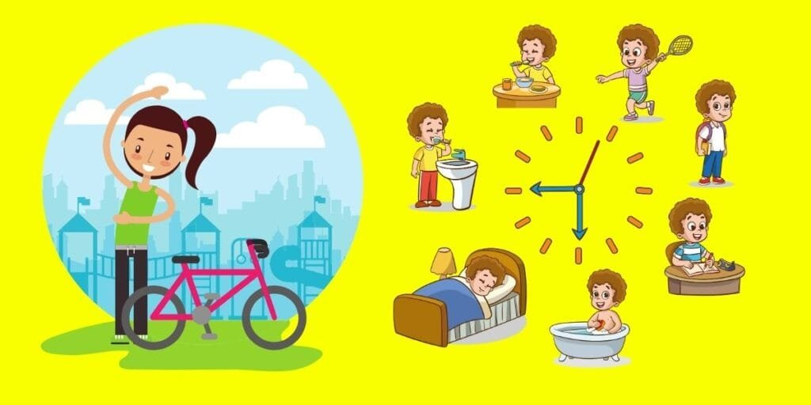

At St. Vincent’s School, we prioritize the overall well-being of our students. Good H habits are fundamental for a child’s growth, academic success, and lifelong wellness. By adopting healthy practices, students can stay energetic, focused, and resilient to illnesses. This blog provides practical tips and guidance to promote health and hygiene awareness among students.

Why Health and Hygiene Awareness Matters
Health and hygiene go hand in hand with academic and personal development. Here’s why they are essential:
- Prevents Illnesses: Proper hygiene reduces the risk of infections and diseases.
- Boosts Confidence: Personal cleanliness enhances self-esteem and social interactions.
- Improves Academic Performance: Healthy students can concentrate better and perform well in school.
- Promotes Good Habits: Early awareness lays the foundation for lifelong healthy practices.

Daily Hygiene Practices for Students

1. Maintain Personal Cleanliness
- Shower regularly to keep your body fresh and clean.
- Wash your hands with soap and water before meals, after using the restroom, and after outdoor activities.
- Brush your teeth twice daily to maintain oral hygiene and prevent cavities.

2. Wear Clean Clothes
- Change clothes daily and ensure they are properly washed and ironed.
- Wear clean socks and polish your shoes to avoid unpleasant odors and infections.

3. Keep Nails and Hair Neat
- Trim your nails weekly to prevent the accumulation of dirt and germs.
- Keep your hair clean and tidy, washing it regularly to avoid dandruff or lice.

Healthy Eating Habits

1. Eat a Balanced Diet
- Include fruits, vegetables, whole grains, and proteins in your meals.
- Avoid junk food and sugary snacks that can harm your health.

2. Stay Hydrated
- Drink plenty of water throughout the day to stay hydrated and maintain energy levels.
- Carry a water bottle to school to ensure regular water intake.

3. Eat Breakfast Daily
- A nutritious breakfast provides energy and improves concentration during classes.

School Hygiene Practices

1. Clean Classroom Environment
- Keep your classroom tidy and dispose of waste in designated bins.
- Avoid littering in school premises to maintain a clean and healthy environment.

2. Sanitize Frequently
- Use hand sanitizers if soap and water are unavailable.
- Clean and disinfect your desk and belongings regularly.

3. Avoid Sharing Personal Items
- Do not share water bottles, towels, or combs to prevent the spread of germs.

Physical and Mental Health Awareness

1. Stay Active
- Participate in sports and to boost fitness and immunity.
- Engage in yoga or stretching exercises to enhance flexibility and reduce stress.

2. Get Adequate Sleep
- Ensure 7-9 hours of sleep every night to recharge your body and mind.
- Avoid screen time before bedtime to improve sleep quality.

3. Practice Mindfulness
- Meditate or practice deep breathing to improve focus and reduce anxiety.
- Share your feelings with teachers or counsellors to address emotional concerns.

Role of Parents and Teachers
Parents and teachers play a critical role in instilling health and hygiene awareness.

Here’s how they can contribute:
- Lead by Example: Demonstrate good hygiene habits for children to emulate.
- Educate Regularly: Discuss the importance of health and hygiene through interactive sessions and activities.
- Encourage Responsibility: Teach students to take ownership of their hygiene and well-being.
Conclusion: Health and hygiene are vital aspects of a child’s development. At RK Modern School, we are committed to creating a safe and healthy environment for our students. By following these tips, students can cultivate habits that ensure their well-being and set the stage for a successful future.
“HEALTHY MIND HAPPY LIFE”
WEEK 6- HEALTH EXPERT INTERACTION:
We organise workshops or talks with doctor under some topics are as follow:
1. Adolescent health
Adolescent health refers to the physical, mental, and social well-being of individuals aged 10 to 19 or up to 21 in some clinical contexts. It goes beyond the mere absence of disease, focusing on the critical growth, identity formation, and behavioural habits that shape a person's lifelong quality of life.
Why This Stage Matters
Adolescence is a transformative phase characterized by rapid physical, cognitive, and psychosocial development. Health interventions during this period are essential for several reasons:
- Behavioural Foundation: Patterns related to diet, substance use, and physical activity are established during these years.
- Preventable Risks: Leading causes of death and disability in this demographic—such as traffic injuries, self-harm, interpersonal violence, and maternal complications—are largely preventable and treatable.
- Long-Term Impact: Investing in adolescent well-being sets the groundwork for healthy adulthood and protects the health of subsequent generations.
- To design a successful adolescent health outreach campaign, you must utilize human-centred design to co-create message strategies directly with youth, shifting their role from passive recipients to active partners. According to WHO and UNICEF guidelines, an effective campaign needs multi-sectorial touch points (schools, community, digital spaces) paired with non-judgmental, inclusive visuals to drive genuine behavioural changes.
2.STRESS MANAGEMENT
Stress management involves a range of techniques, therapies, and lifestyle strategies designed to help you control your stress levels, improve how you react to difficult situations, and build long-term resilience. The goal is to bring balance to your life, allowing you to meet challenges head-on while protecting your physical and mental well-being.
Effective stress management strategies generally fall into three main categories:
1. Removing or Changing the Stressor
Instead of just reacting to stress, you can take control of your environment and responsibilities.
- Set boundaries: Learn to say "no" to commitments that overload your schedule.
- Time management: Break larger, overwhelming tasks into smaller, manageable steps.
- Avoid triggers: Limit time with people who cause you distress, and reduce exposure to topics or environments that agitate you.
- 2. Managing Your Physiological Response
When stress triggers your "fight-or-flight" response, your body releases cortisol. You can use quick physical and mental techniques to calm your nervous system. Breathing and Relaxation: Deep breathing exercises, meditation, and progressive muscle relaxation help lower your heart rate and ease physical tension.
- Mindfulness: Grounding yourself in the present moment can help de-escalate anxiety.
- 3. Building Resilience
Adopting long-term healthy habits builds a foundation that makes you stronger in the face of future stress.
Lifestyle changes: Regular physical activity (like yoga or walking) releases endorphins that boost mood, while a balanced diet supports hormone regulation.
- Prioritizing sleep: Aiming for consistent, restorative rest (usually 7+ hours for adults) is vital for cognitive function.
- Social support: Stay connected with loved ones or join support groups, and seek out professional help if stress feels too overwhelming to handle alone.

3. FIRST AIDS
A first aid case refers to an immediate, short-term treatment for a minor injury or illness that can be administered on-site using simple supplies. It resolves quickly and typically does not require professional medical attention, prescription medication, or time away from work.
Common Minor Workplace Treatments
According to Safeopedia, the following procedures are classified as first aid cases:
- Minor Cuts and Scrapes: Clean the wound with antiseptic wipes, apply antibiotic ointment, and cover with adhesive bandages.
- Minor Burns: Cool the affected area with running cool water for 10–15 minutes, cover with a sterile, non-stick dressing, and avoid applying ice.
- Eye Irritation: Flush the eye with clean water or saline for at least 15 minutes to remove dust or chemicals.
- Sprains and Strains: Apply a cold compress or ice pack to reduce swelling and immobilize the joint temporarily.

Regulatory and Safety Requirements
In occupational safety, effectively managing first aid involves preparing for the worst:
- Kits & Facilities: Workplaces must maintain appropriately stocked first aid kits, including items like roller bandages, gauze pads, tweezers, and emergency blankets.
- Emergency Response Times: OSHA requires employers to ensure that a trained first-aid provider can respond to serious emergencies within 3 to 4 minutes.
- Blood borne Pathogens: Employees designated to provide first aid must be trained on blood borne pathogen standards to avoid infection.

4. LIFESTYLE DISEASES

Lifestyle diseases (or non-communicable diseases) are long-term, preventable health conditions primarily driven by daily habits, environmental factors, and behaviour. They are typically caused by physical inactivity, poor diet, chronic stress, tobacco use, and excessive alcohol consumption, and they develop slowly over time. Lifestyle diseases, or non-communicable diseases (NCDs), account for over 60% of deaths in India. Driven by rapid urbanization, poor diets, and sedentary habits, prevalent conditions include cardiovascular diseases, Type 2 diabetes, obesity, hypertension, and mental health disorders. Surveys indicate nearly half the adult population now reports metabolic or cardiovascular ailments.
Key Drivers in India
- Dietary Shifts: Traditional, high-fibre diets are increasingly replaced by energy-dense, highly processed foods high in sugar, fat, and salt.
- Physical Inactivity: Long working hours, reliance on tech, and sedentary commutes have drastically reduced physical activity.
- Stress and Pollution: High stress, poor sleep, and urban pollution exacerbate the onset of these diseases.
- Lack of Awareness: "Silent" progression means many Indians remain unaware of risks until complications arise.
Major Preventative Strategies
You can significantly lower your risk of developing these disorders by adopting a few mindful, daily routines:
- Diet: Eat a balanced diet rich in whole grains, fibre, and fresh produce while avoiding highly processed and sugary foods. Physical Activity: Incorporate regular exercise—such as brisk walking, yoga, or strength training—into your daily routine.
- Habits: Limit alcohol consumption and completely avoid tobacco use.
- Stress Management: Prioritize 7-8 hours of quality sleep per night and utilize stress-relief practices such as meditation or deep breathing.
- Regular Health Screenings: Because NCDs progress silently, routine health check-ups and early screenings are vital for timely detection.

6. PREVENTIVE HEALTH CARE
Preventive healthcare focuses on stopping diseases before they start rather than just treating them. It includes routine check-ups, screenings (e.g., blood pressure, cholesterol, diabetes, and cancer), and immunizations. Catching potential issues early can significantly lower healthcare costs and improve long-term quality of life.
Preventive health is typically divided into three categories to help avoid chronic conditions:
Primary Prevention: Actions to prevent disease entirely, such as maintaining a balanced diet, staying physically active, avoiding tobacco, and getting routine immunizations.
Secondary Prevention: Early detection of health issues before noticeable symptoms appear, usually through routine health check-ups and cancer screenings. Tertiary Prevention: Managing and treating diagnosed, symptomatic conditions to prevent further complications or disability.
WEEK 7- COMMUNITY OUTREACH ACTIVITY:
Community outreach activities are organized initiatives designed to connect organizations—such as non-profits, schools, or businesses—with the public. Their primary goal is to provide direct assistance, education, or resources to underserved populations while building trust and addressing specific community needs.
COMMUNITY VISITING
"Community visiting" can refer to several different experiences depending on your goal. Whether you are looking for volunteer roles checking on vulnerable individuals, immersive cultural travel, or conducting healthcare or social outreach, the approach differs entirely. Visit nearby communities like old age home, shelters, and local neighbourhoods to conduct awareness drives. Organizing a community visit to an old age home is a highly impactful initiative that fosters intergenerational connection and brings joy to isolated elders. To plan a successful and respectful visit, follow these key steps:
Select a Facility & Get Approval: Contact local facilities in the Guwahati area, such as Helping Hand Old Age Home (Vinobha Nagar) or SwastiOldage Home, well in advance. Always coordinate with the administration to schedule a date, establish visiting hours, and confirm group size limits.
Assess Needs & Plan Activities: Ask the facility administration what they need most, such as groceries, medical supplies, or toiletries. Plan engaging activities like storytelling, gentle arts and crafts, or a musical performance.
Prioritize Sensitivity: Brief your community members to be respectful, empathetic, and patient. Avoid asking prying questions about why the residents are in the home; instead, focus on active listening and simply enjoying their company.
HEALTHY PRACTICES FOR THE COMMUNITY
Distributing informative material and interacting with community members requires a clear, structured approach to ensure your health message is both well-received and legally compliant.
Core Action Steps
- Define Objectives: Choose one specific health topic per campaign (e.g., vaccination, nutrition, or hygiene) to avoid overwhelming your audience.
- Select Channels: Match your delivery method to your target demographic, using physical flyers for seniors and social media or messaging apps for youth.
- Simplify Language: Translate complex medical jargon into universal, everyday terms that non-native speakers can easily understand. Create Feedback Loops: Establish Q&A sessions, suggestion boxes, or digital polls to let community members drive the conversation.
- Verify Information: Ensure all distributed material strictly aligns with current guidelines from official public health authorities like the WHO or CDC.
- Material Distribution Methods
- Physical Hand-outs: Place brochures at local clinics, community centres, libraries, and religious spaces.
- Digital Outreach: Share short info graphics, factual bullet points, and instructional videos via community What Sapp groups or email newsletters.
- Visual Displays: Hang clear posters with minimal text and high visual impact in high-traffic local areas.
Community Engagement Strategies
- Interactive Workshops: Host live demonstrations, such as healthy cooking classes or proper hand washing drills.
- Listening Sessions: Allow residents to voice their specific health concerns and barriers to healthy living before offering solutions.
- Local Partnerships: Collaborate with trusted community leaders, elders, or local doctors to build immediate trust and credibility.
WEEK 8- HEALTH CHECK- UP/SUPPORT INITIATIVE:
In Silchar, preventive health check-ups and medical screenings are primarily provided through social organizations, medical foundations, and charity-driven institutions rather than traditional medical NGOs.
Top providers for organized and subsidized medical check-ups in the Cachar district include:
Cachar Cancer Hospital and Research Centre (CCHRC): Located in Meherpur, they run community outreach and nurse-driven screening OPDs, offering free cancer screenings and preventive health programs.
Rotary Club of Silchar: Frequently organizes free specialized health check-up camps (e.g., heart, dental, and gynaecology) in association with local medical societies.
- Heart Care Society of Assam (Barak Valley Chapter): Regularly collaborates with local organizations to host free cardiac check-up camps and routine investigations. Disha Foundation: A recognized local NGO that frequently initiates medical, mental health, and social welfare awareness camps.
For comprehensive, subsidized diagnostic check-ups (like routine blood panels, ECGs, and sonography), you can rely on trusted local diagnostic and healthcare centres:
- Apollo Clinic Silchar: Located on Silchar Medical College Road, Meherpur, offering dedicated executive health check-up packages.
- Dr LalPathlabs: Available across multiple locations in Silchar, providing pre-marital, full-body, and corporate health check-ups.
- Redcliffe Labs: Offers affordable "Fit India" full-body tests with the convenience of free home sample collection across the Cachar region.

WEEK 9- INNOVATION AND HEALTHY LIVING:

Innovative healthy living is all about integrating cutting-edge technology and modern bio solutions with timeless lifestyle habits. It involves leveraging wearable tech (like smart rings) to monitor your sleep and stress, upgrading nutrition with targeted probiotics and quick-dissolving vitamin strips, and optimizing your daily environment with air purifiers and filtered water.
The World Health Organization emphasizes that these forward-looking steps—combined with stress management, hydration, and regular activity—form the core of modern, proactive self-care. Localized health optimization is highly accessible, blending traditional wisdom like regional whole foods with modern digital tracking tools. Encourage students to develop innovative ideas for improving community health such as kitchen gardens, fitness challenges, healthy campaigns,stress-relief corners or digital awareness tools.
1.KITCHEN GARDENS

Encouraging students to innovate for community health through kitchen gardens provides hands-on, sustainable solutions to local nutrition and food security. By directly engaging with nature, students can prevent micronutrient deficiencies, reduce food costs, and foster a lifelong appreciation for healthy, organic diets.
Why Kitchen Gardens Matter
- Improved Nutrition: Freshly grown, chemical-free vegetables combat deficiencies (like iron and Vitamin A) right at the grassroots level.
- Reduced Food Expenses: Produce harvested from these gardens significantly decreases household vegetable costs.
- Holistic Education: Students gain practical skills in biology, ecology, mathematics, and sustainable farming while promoting environmental conservation.
- Ripple Effect: Children pass their agricultural knowledge to their families, promoting home-based and rooftop gardens in urban and rural settings alike.
How Students Can Innovate
- Low-Cost Container Gardening: Students living in dense or land-scarce urban areas can design vertical gardens using recycled plastics, old tires, or repurposed containers.
- Smart Irrigation: Introduce simple, water-saving technologies like drip irrigation or clay-pot (pitcher) irrigation to conserve water and maximize yield.
- Natural Bio-Pesticides: Encourage students to innovate by creating natural repellents using neem, garlic, or chili to avoid harsh chemical fertilizers.
- Compost Systems: Set up micro-composting bins using kitchen and garden waste to turn organic matter into rich soil, minimizing landfill waste and reducing carbon emissions. Seed Banks: Students can collect, store, and exchange indigenous seeds that are resilient to local climates and require fewer fertilizers.

2.FITNESS CHALLENGES

Encouraging students to pioneer community health initiatives—such as collaborative fitness challenges—transforms them from passive learners into active wellness leaders. It bridges the gap between academic life and physical vitality while actively addressing prevalent health concerns.
Key Strategies to Inspire Student-Led Initiatives
- Gamified Fitness Events: Design physical education and health drives to be highly interactive. Activities like alphabet-themed exercise stations, stair-climbing races, or virtual tracking competitions use creativity and fun to disguise physical exertion.
- Student Co-Created Programs: Surveys reveal that fitness initiatives adherence skyrockets when students co-design the programs. Allow them to choose the activities, session durations, and performance rewards.
- Community-Wide Interventions: Students can organize large-scale community challenges, like the "Sweat for Success" initiative, which cater to varying fitness levels by encouraging walking, jogging, or yoga.
- Technology & App Integration: Encourage the use of wearable tech and apps (e.g., MyFitness Pal) for creating campus-wide leader boards and fostering friendly competition.
Institutional Support & Frameworks
- WHO Health Promoting Schools: Align projects with the World Health Organization (WHO) guidelines to build environments that naturally foster physical, mental, and social well-being.
- Public Health Clubs: Structured programs—like the Public Health Clubs initiative—offer an excellent framework for high school and university students to plan health-focused community activities.
- Innovation Pitching Events: Encourage students to scale their physical and mental health ideas through events like the United Nations Development Programme (UNDP) Youth Co:Lab National Innovation Challenge.

3. HEALTHY MEAL CAMPAIGNS

Empower students to champion community health by challenging them to design, test, and pitch their own wellness initiatives, like student-led healthy meal campaigns. Transform classrooms into incubators for public health using hands-on design thinking, real-world community assessments, and peer-to-peer marketing strategies.

1.Connect with Real-World Experts
Bring in local nutritionists, farmers, and public health officials to mentor student groups. Experts can offer insights on nutritional needs, food sourcing, and budget management. Having professionals validate their ideas gives students confidence and ensures their health campaigns are practical, safe, and culturally relevant.
2. Launch Peer-to-Peer Marketing Campaigns
Encourage students to use the media they consume daily to promote their ideas. Have them create short-form videos, design social media campaigns, or host school-wide taste tests and recipe competitions. This experiential learning builds both communication skills and public health advocacy.
3. Integrate with the Community
Move the campaign beyond the school gates. Students can collaborate with local grocers or farmers' markets to distribute recipe cards for affordable, locally sourced healthy meals. They can also partner with community centres or food banks to host cooking demonstrations.
4. Provide Incentives and Recognition
Recognize student innovation by showcasing their campaigns to the wider community. Offer opportunities for students to present their pitches to school boards or city councils. Celebrate their work with digital badges, certificates, or seed funding to pilot their healthy meal campaigns in the actual school or local district.
4. STRESS – RELIEF CORNERS

Developing innovative health ideas allows you to create a lasting, positive impact on your school and neighbourhood. By identifying everyday challenges and designing creative solutions, you become an active leader in community wellness.
Brainstorming Innovative Health Ideas
- Stress Relief Corners: Quiet school spaces with beanbags, noise-cancelling headphones, and guided breathing prompts.
- Hydration Stations: Ramified water dispensers that track collective plastic bottles saved to encourage drinking water.
- Green Exercise Tracks: Outdoor walking paths paired with simple, bodyweight exercise stations and nature facts.
- Community Cooking Pop-ups: Mobile carts offering free, quick lessons on preparing healthy meals with local ingredients.
- Digital Detox Lockers: Secure hubs where students can safely store phones during lunch to boost social connection.
- Peer Support Networks: Trained student mentors providing confidential, everyday active listening for peers.

5.DIGITAL AWARENESS TOOLS

By designing digital awareness tools, you can bridge the gap between vital medical information and the people who need it most. Small, innovative ideas can scale into life-saving solutions.
Why Digital Tools Matter
- Massive Reach: Mobile applications and websites instantly connect with thousands of users.
- Real-Time Data: Digital platforms provide immediate health updates during crises.
- High Engagement: Interactive quizzes and gamified challenges make health education memorable.
- Bridges Barriers: Software can instantly translate medical jargon into local languages.

Steps to Bring Ideas to Life
- Identify Needs: Interview local residents about their biggest health information struggles.
- Map the Journey: Sketch how a user will interact with your digital tool.
- Build a Prototype: Create low-fidelity paper sketches or basic digital wireframes.
- Gather Feedback: Test your concept with peers and local healthcare professionals.
- Refine and Pitch: Polish your idea to present to community leaders or investors.

WEEK 10-PARENT AND COMMUNITY ENGAGEMENT:

A student-led Nutrition Awareness Workshop is an excellent tool to bridge the gap between classroom learning and healthy home habits, effectively driving both parent and community engagement. Moving away from dry lectures and adopting a hands-on, interactive format guarantees maximum participation and memorable impact.

1.NUTRITION

The ‘Eat Healthy, Grow Healthy’ program is one of the key projects connecting education and child health. So far, some phases have been successfully implemented, and 18 educational institutions have gone through the accreditation process and had the honour of actively participating in the program. The goal is to continue the program beyond this phase and involve new institutions. Each school and kindergarten contributes in its own way, bringing a unique spirit to the program. The strength of this approach lies in this diversity. Schools and preschool institutions are the foundation of a healthy start to life for every child. Through collaboration with parents, teachers, and the wider community, we work to empower children to develop healthy eating habits and gain the functional knowledge they need to make responsible decisions”.
2. MENTAL WELL- BEING

Community mental health and parenting workshops can encompass a wide variety of topics designed to de-stigmatize mental illness and build resilience.
Core Topics for Parents
- Emotional Regulation: How to model emotional intelligence and help children identify, express, and manage big feelings.
- Screen Time & Digital Wellness: Strategies to reduce excessive screen dependence and cultivate healthy digital habits at home.
- Navigating Anxiety & Stress: Early identification of childhood stress, anxiety, or low self-esteem and how to respond proactively.
- Building Self-Esteem: Equipping parents with communication methods that build trust and emotional security.
Core Topics for the Broader Community
- Stress Management & Burnout: Tools for caregivers and community members to build a self-care toolkit and manage daily pressures.
- Mental Health First Aid: Demystifying mental health basics, recognizing warning signs, and understanding how to connect individuals to professional care.
- Building Support Networks: Fostering community care and collective responsibility in dealing with substance abuse or family distress.
- Intergenerational Communication: Bridging gaps between different age groups to improve relationships and overall family well-being.
  - DIGITAL ADDICTION
Digital addiction workshops provide community leaders and schools with actionable frameworks to curb screen reliance and protect youth mental health. These educational modules address the physiological triggers behind device overuse and offer practical intervention strategies for families.
Core Workshop Topics
- The Neuroscience of Screens: Explaining how apps hijack dopamine pathways.
- Identifying Warning Signs: Recognizing tech-induced insomnia, anxiety, and social withdrawal.
- Healthy Boundary Setting: Implementing "screen-free zones" and device curfews.
- Alternative Engagement: Substituting screen dependency with sports, arts, and hobbies.
- Modelling Behaviour: Helping parents audit and reduce their own tech usage.

4.PREVENTIVE HEALCARE
Preventive healthcare workshops for parents and community members shift the focus from treating illnesses to building long-term, everyday wellness habits.
The list below outlines comprehensive workshop topics designed for community settings, organized by target audience and focus area.
👶 Parent-Focused Workshops
- Childhood Illness Prevention: Recognizing early symptoms, learning proper hand washing techniques, and understanding vaccine schedules.
- Paediatric Nutrition & "Habit Swapping": Teaching families how to substitute sugary drinks and processed foods with nutrient-dense alternatives through interactive group activities. Digital Wellness & Screen Time: Managing the physical impact of a sedentary lifestyle and tech usage on children's eyesight, sleep patterns, and posture.
- Developmental Milestones & Screening: Helping parents identify early signs of physical or learning challenges through guided self-assessment tools.
🏡 Family & Home Well-Being
- Home Safety & First Aid: Practical, hands-on training for choking response, infant CPR, childproofing rooms, and poisoning prevention.
- Sleep Hygiene For All Ages: Exploring the deep connection between consistent sleep routines, immunity boosting, and childhood cognitive development.
- Environmental Health at Home: Identifying and mitigating indoor health risks like mould, heavy metals, second-hand smoke, and unsafe drinking water.

5.SUBSTANCE ABUSE AWARENESS

Local community and parenting workshops on substance abuse awareness are highly effective when partnered with specialized regional rehabilitation centres and non-profits in the Guwahati region. These localized programs focus on early identification, open communication, and building youth resilience to resist peer pressure.
In and around Guwahati, Assam, several professional bodies offer direct educational seminars, counselling, and community-based workshops:
- Athena Behavioural Health Guwahati: Offers clinical, transparent, and multi-disciplinary workshops, psychiatric evaluations, and family counselling for sustainable recovery.
- Nirmaan Rehabilitation Facility: Active in the local community alongside the NCB (Narcotics Control Bureau) of Assam, frequently holding public awareness talks and educational sessions.
- Rehabs.in Guwahati: A comprehensive directory listing over 30 verified de-addiction and rehabilitation facilities (such as Abhigya De-Addiction and Revival Wellness) that facilitate community outreach and parent-support workshops.
- NIDA (National Institute on Drug Abuse): Provides evidence-based lesson plans, conversation starters, and interactive materials used in workshops for educators and parents.
- UNODC South Asia: Partners regularly with the Ministry of Social Justice and Empowerment in Assam and Manipur to train social workers and leaders in community-based drug prevention programs.

6.HEALTHY LIFESTYLE

Host impactful, community-focused healthy lifestyle workshops tailored for parents by blending practical skill-building with actionable daily routines. Key session topics include Balanced Nutrition & Meal Prep, Family Fitness & Active Play, Screen Time & Digital Wellness, and Stress Management & Family Resilience.
These topics can be structured into practical, hands-on community workshops:
1. Practical Cooking & Nutrition
- Focus: Transition away from traditional lectures by using interactive family cooking classes and visual learning.
- Actionable topics: Healthy tiffin packing, budget-friendly meal planning, and decoding food labels.
- 2. Physical Activity & Outdoor Play
- Focus: Focus on "how-to" strategies to integrate movement into everyday family life rather than just theory.
- Actionable topics: Active play sessions, local nature scavenger hunts, and finding safe community spaces for recreation.
- 3. Digital Wellbeing and Screen Management
- Focus: Address modern parenting challenges by setting healthy technology habits.
- Actionable topics: Designing tech-free zones, regulating screen time, and recognizing early signs of digital addiction.
- 4. Emotional Intelligence and Self-Care
- Focus: Build parental self-efficacy and resilience to reduce the stress that often hinders healthy lifestyle choices.
- Actionable topics: Recognizing and managing childhood tantrums, fostering empathy, and practicing parental self-care.

WEEK 11- EVALUATION AND IMPACT STUDY:

Evaluation and impact assessment are systematic processes used to measure the effectiveness, value, and outcomes of a program, policy, or intervention. While evaluation tracks ongoing performance against goals, impact assessment determines the exact changes that can be directly attributed to the intervention, rather than outside factors. These assessments help organizations understand what works, allowing them to optimize resources, scale successful programs, and justify decisions with concrete evidence. Key components and methodologies include:
- Formative vs. Summative: Formative evaluations provide feedback during a project to allow for mid-course corrections, whereas summative evaluations assess the overall outcomes after the project concludes.
- Causal Attribution: To prove impact, evaluators compare observed outcomes with a "counterfactual"—what would have happened without the intervention.
- Methodological Approaches: This often involves experimental designs like Randomized Controlled Trials (RCTs) or quasi-experimental methods like Difference-in-Differences (DID) and Propensity Score Matching (PSM).
- Multi-Criteria Appraisal (MCA): Some frameworks avoid monetizing outcomes, opting instead to balance social, economic, and environmental impacts alongside trade-offs in decision-making.
ANALYSZE IMPROVEMENTS IN HEALTH AWARENESS AND OUTREACH IMPACT.

Improving health outcomes relies heavily on maximizing the impact of community outreach. By targeting specific social determinants of health and bridging service gaps, impactful outreach shifts healthcare from reactive treatment to proactive prevention.
Analysing improvements across public health and outreach initiatives involves measuring specific drivers, program indicators, and community-level results.
1. Key Performance Indicators (KPIs)
Measuring the success of an outreach program helps ensure long-term sustainability and demonstrates the value of interventions. Key metrics include:
Reach and Penetration: The percentage of the target population (e.g., underserved communities, specific demographics) that actively uses the service.
- Screening and Detection Rates: The number of individuals screened compared to the incidence of early-stage disease diagnoses (e.g., hypertension, diabetes).
- Behavioural and Lifestyle Changes: Quantifiable metrics such as increased immunization coverage, improvements in medication adherence, and adoption of healthier diets.
- 2. Driving Factors in Outreach Impact
Several strategic enablers significantly boost the efficacy of health programs and drive positive community outcomes:
Community Health Workers (CHWs): Leveraging local, peer-to-peer CHWs builds essential trust and overcomes cultural or socioeconomic barriers to care.
- Digital Ecosystems: Integrating mobile Health (mobile health), localized telemedicine, and interoperable tracking systems coordinates service delivery and tracks follow-up care. Collaborative Coalitions: Partnering with local government bodies, non-profits, and educational organizations expands the resources available to address systemic social needs.
- 3. Community Outcomes and Health System Readiness
Successful outreach does not just treat illness—it transforms the community. Positive outcomes include:
Reduced Disparities: Targeted mobile clinics and door-to-door visits reduce geographical and financial inequities in healthcare access.
Improved Health Literacy: Continuous educational outreach significantly lowers the rates of chronic condition hospitalizations and emergency room visits.
Social Empowerment: Effective outreach builds community capacity by empowering members to take charge of their own well-being and advocate for better local services.
WEEK 12- PRESENTATION AND SUSTAINABILITY PLAN:
A project presentation and sustainability plan must clearly connect your initial deliverables to long-term value. It demonstrates to stakeholders and sponsors that your project is financially viable, socially responsible, and designed to thrive long after the initial funding or launch phase concludes.
To effectively outline your project outcomes and sustainability plan, structure your presentation into these core pillars:
1. Defining Project Outcomes
Clearly separate your short-term deliverables from your long-term, systemic impacts.
- Outputs (Deliverables): The direct, tangible products of your work (e.g., a new solar array, a completed training curriculum, or a newly built community centre). Outcomes: The medium-term changes that occur as a direct result of your outputs (e.g., a 20% reduction in local facility energy costs or increased skill retention among staff).
- Impacts (Long-term): The broader, ultimate goal (e.g., lower community carbon emissions, long-term poverty alleviation).
- 2. The Sustainability Strategy
Prove that your project can maintain its benefits without relying on endless inputs of money or external resources.
Financial Sustainability: Detail your strategy for revenue generation, cost-sharing, or integration into institutional/municipal operating budgets.
Operational Capacity: Highlight the training, policy changes, or local partnerships (e.g., local NGOs or government bodies) that ensure smooth day-to-day management post-launch.
Environmental/Social Viability: Briefly summarize how the project respects environmental limits and improves community well-being over time.
3. The Exit & Transition Plan
If your project requires a handover (such as a grant-funded initiative transferring control to a local committee), explicitly lay out the timeline.
Transition Phases: Break down the handover process into clear chronological steps.
- Risk Management: Identify potential vulnerabilities (e.g., funding shortages or leadership turnover) and list the mitigation controls you have in place.
- 4. Monitoring and Evaluation (M&E)
Provide stakeholders with a clear method to measure, verify, and report success. Key Performance Indicators (KPIs): Define the metrics you will track (e.g., user adoption rates, maintenance costs, or carbon footprint reduction).
- Reporting Framework: Specify how often you will audit the project and who will be responsible for data collection.
SUCCESS STORIES
Community health outreach in Silchar relies heavily on sustained, university-backed and public-private models that empower local stakeholders.
Notable initiatives in and around Silchar include:
- Academic-Driven Outreach: Assam University (Silchar) runs active medical outreach, such as the Department of Social Work's cancer awareness and maternal health programs in the Silcoorie and Silcoorie Tea Garden areas.
- Public-Private Partnerships: Cachar Cancer Hospital & Research Centre (CCHRC) and the INTAS Foundation regularly collaborate with local bodies like the Silchar Municipal Corporation to connect waste management with public health awareness.
- Mega Health Camps: Udharbond and surrounding constituencies regularly host large-scale "SushrushaSetu" medical camps where specialists from Silchar Medical College screen and treat over 50 diseases for rural communities.

FUTURE ROADMAP

This comprehensive road map outlines a phased sustainability plan for community health outreach in Silchar, Assam. It blends local healthcare infrastructure with grassroots, sustainable interventions designed to empower Barak Valley communities.

Future Road Map
Phase 1: Needs Assessment & Pilot (Months 1 - 6)
- Conduct hyper-local health surveys to identify the primary morbidities (e.g., malnutrition, anaemia, TB, malaria) specific to each targeted GaonPanchayat.
- Establish baseline metrics tracking maternal mortality and chronic disease prevalence.
- Phase 2: Implementation & Capacity Building (Months 7 - 18)
- Roll out the Mobile Medical Units and Telemedicine Hubs.
- Train 100+ local women and youth leaders in primary triage and behavior change communication (BCC).
- Phase 3: Integration & Scale (Months 19 - 36)
- Merge local outreach data directly with district-level National Health Mission (NHM) databases.
- Hand over basic clinical operations to trained village committees while the central team focuses on advanced diagnostics and capacity building.

KEY DELIVERABLES

1.BASELINE AND ENDLINE SURVEY REPORTS:

Baseline and end line survey reports are evaluation tools used in project management to measure change, consisting of a baseline report (initial conditions before a project starts) and an end line report (final impact after the project finishes).
Baseline Survey Reports
- Starting point: Captures the conditions, needs, and numbers of a target group before any project work begins.
- Core purpose: Creates a fixed point of reference so project teams know what needs fixing and can set realistic goals.
- Key data: Gathers facts on income, health, education, or local habits

End line Survey Reports

- Final check: Takes place right after a project ends or near its completion.
- Core purpose: Measures real changes and total impact by comparing new data directly against the old baseline data.
- Key data: Shows if the project met its goals, helped the community, or changed behaviours.

2.COMMUNITY HEALTH ASSESSMENT REPORT:

A community health assessment report is a documented overview that details a population's health status, identifies key local needs and risks, and outlines available health resources. It relies on data collection, community surveys, and stakeholder input to guide public health improvements.
Key Report Sections
- Executive Summary: Highlights main findings, priority health issues, and high-risk groups.
- Methodology: Explains how data was gathered using surveys, focus groups, or public health records.
- Health Data & Findings: Shows local disease trends, death rates, and social risk factors.
- Resource Inventory: Lists local clinics, hospitals, and programs available to help.
- Action Plan: Sets priorities and guides future community health projects

3. AWARENESS CAMPAIGN MATERIALS (POSTERS, VIDEOS, PAMPHLETH, SLOGANS):

Effective community health outreach requires targeted awareness campaign materials including bold posters, engaging video scripts, informative pamphlets, and memorable slogans.
Posters and Visual Aids
- Design elements: High-contrast colours, minimal text, and simple icons representing key behaviours (e.g., hand washing, vaccination schedules).
- Placement: Community centres, local markets, bus stops, and clinic waiting rooms.
- Content focus: Step-by-step disease prevention guides or emergency health hotline numbers.

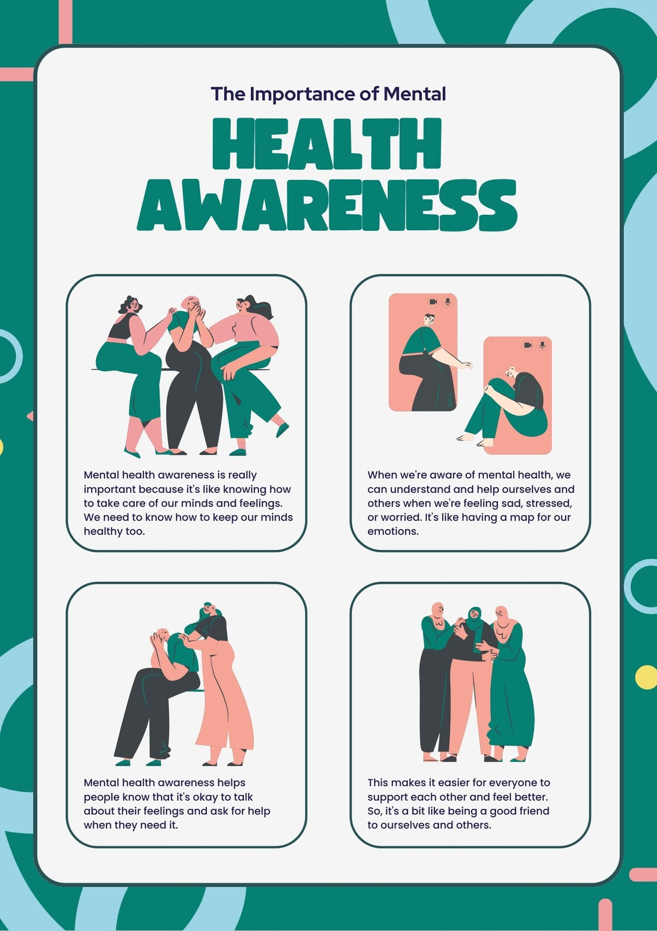

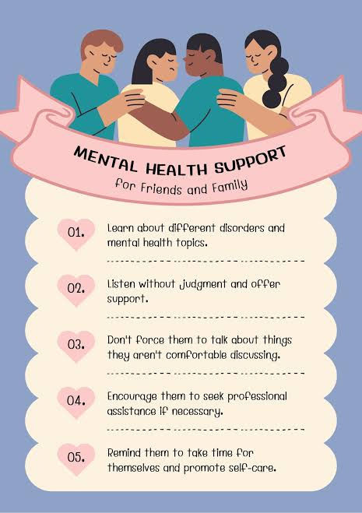

Video Content Ideas
- Short reels (30-60 seconds): Quick myth-busting clips addressing local health misconceptions.
- Demonstration videos: Visual guides on safe drinking water preparation, oral rehydration therapy (ORT), or proper mask-wearing/hygiene.
- Testimonials: Short clips featuring trusted local community leaders or healthcare workers sharing personal health success stories.
Pamphlet and Brochure Layouts
- Fold style: Tri-fold format using simple, everyday language and local dialects.
- Core sections: What the health issue is, early warning signs, local clinic addresses, and operating hours.
- Action steps: Bulleted instructions on when and where to seek professional medical help.

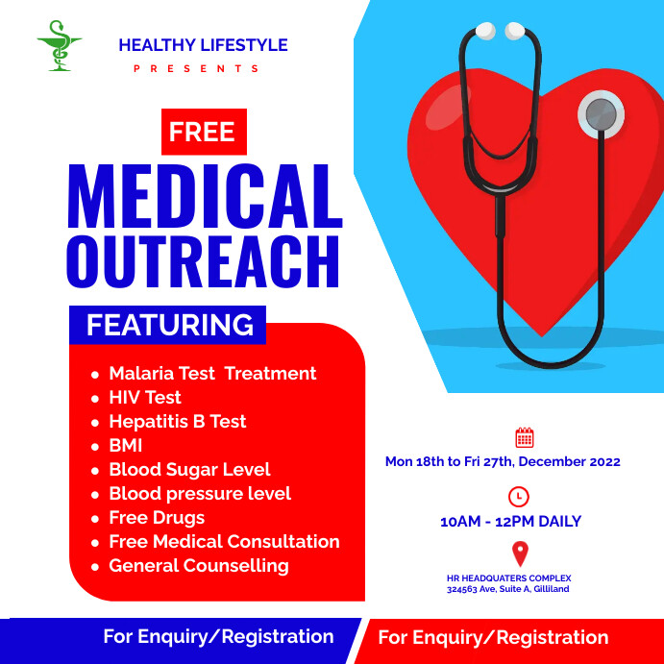

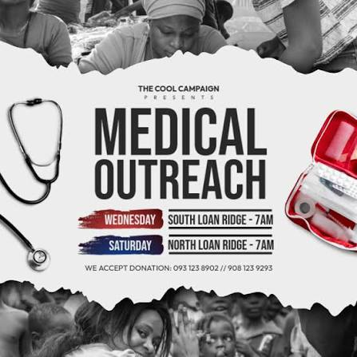
Catchy Health Slogans
- "Clean hands, healthy lands, safe and happy family plans."
- "Health is wealth, protect it with care."
- "Eat fresh, stay fit, let wellness be your habit."
- "Early care stops disease there."

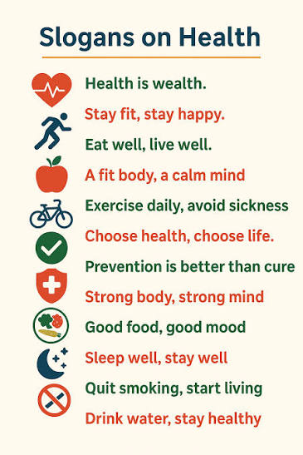

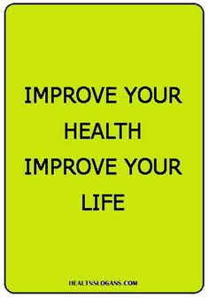

4.WORKSHOP AND HEALTH CAMP REPORTS:

A community health outreach awareness and health camp provides essential medical services, health screenings, and preventive education. Key components include general medical check-ups, diagnostic testing, and health literacy workshops.
Core Services Provided
- Medical Screenings: Blood pressure checks, blood sugar tests, and chronic disease evaluations.
- Specialist Consultations: General medicine, eye check-ups, and paediatric evaluations.
- Preventive Care: Free distribution of essential medicines, vaccination drives, and nutritional counselling.
Awareness and Education
- Health Hygiene: Workshops on personal sanitation, safe drinking water, and healthy lifestyles.
- Disease Prevention: Counselling on managing non-communicable diseases (NCDs) and recognizing early symptoms.
- Government Schemes: Information dissemination regarding public health programs and benefits.

5.ATTENDANCE RECORDS AND PARTICIPATION DATA:
Attendance records and participation data in community health outreach track program reach, engagement trends, and service utilization using core components: registration logs, demographic tallies, and service uptake metrics.
Types of Data Collected
- Client Registration Logs: Names, contact details, ages, and genders of participants recorded at arrival.
- Service Tally Sheets: Counts for screenings, vital signs taken, immunizations given, and medical referrals made.
- Session Tracking: Dates, event locations, total headcounts, and repeat visitor tallies.
Key Uses of Outreach Data
- Resource Planning: Helps adjust medical supplies, staffing, and future scheduling based on actual turnout.
- Equity Assessment: Identifies which social or age groups miss out on care so teams can change their focus.
- Program Evaluation: Measures total community engagement over time to report results to health authorities.

6.PHOTOGRAPHIC AND VIDEO DOCUMENTATION:

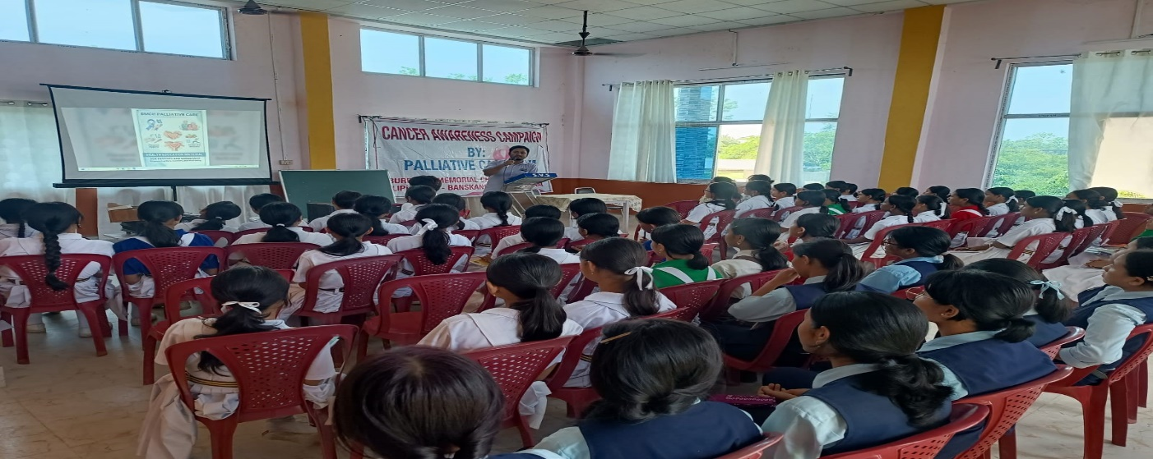
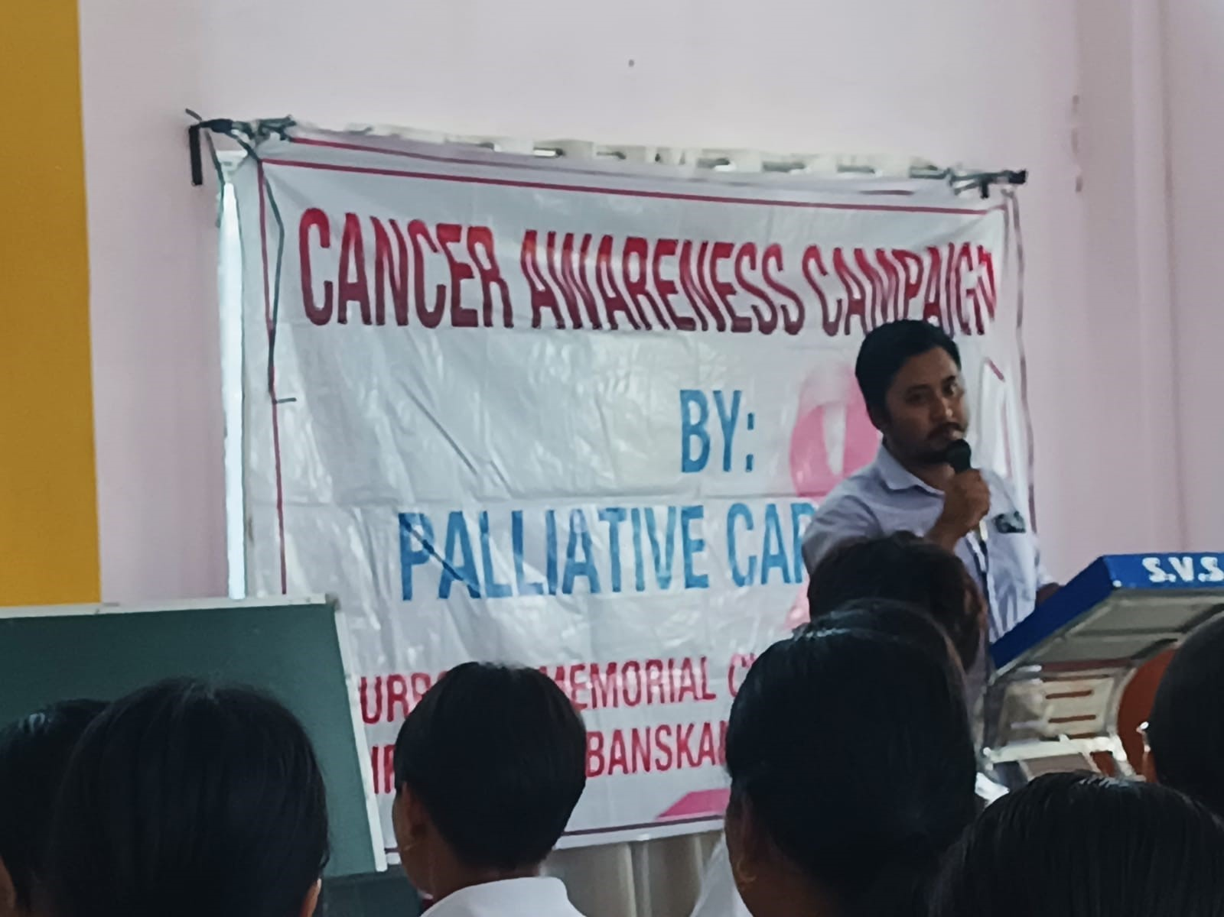

7.STUDENT REFLECTION JOURNALS OR PORTFOLIOS:
Student reflection journals and portfolios in community health outreach are powerful tools that help learners track personal growth, build cultural humility, and connect field experiences with medical or public health theory. They bridge the gap between classroom teaching and real-world challenges in local neighbourhoods.
Core Components of Reflection Journals
- Description (What happened?): Noting facts, specific patient or family interactions, and daily outreach activities without heavy judgment.
- Interpretation (So what?): Analysing feelings, confronting personal biases, recognizing cultural differences, and understanding why a health gap exists.
- Application (Now what?): Planning future actions, improving communication skills, and finding ways to support underserved groups better next time.
Key Elements of Portfolios
- Fieldwork Evidence: Photos of educational posters, attendance logs from health camps, or summaries of health literacy talks.
- Supervisor Feedback: Evaluations and notes from community guides, nurses, or project leaders.
- Self-Assessments: Final essays or checklists where students measure their own progress in empathy, clinical reasoning, and civic learning.

8.COMMUNITY OUTREACH RECORDS AND TESTIMONIALS:
Community health records and testimonials track outreach impact, focusing on service delivery logs and patient feedback. Essential components include service logs, demographic tallies, and beneficiary stories.
Core Records Maintained
- Activity Logs: Dates, locations, and type of camp (e.g., eye, dental, or blood pressure screening).
- Headcounts: Number of individuals registered, diagnosed, treated, or referred to regional primary health centres.
- Supply Tracking: Inventories of distributed items like medicines, nutritional packets, or insecticide-treated nets.
- Types of Testimonials
- Patient Narratives: Personal accounts from local residents regarding improved disease management or early diagnosis.
- Volunteer Feedback: Observations from community health workers on shifts in local health literacy and trust.
- Partner Insights: Evaluations from local leaders on the accessibility of mobile medical units.
9.INNOVATIVE HEALTH INITIATIVE PROPOSALS:
The Innovative Health Initiative (IHI) funds cross-sector health research partnerships, focusing on key community-level priorities like cardiovascular disease prevention, neurodegenerative disease tracking, and personalized local care models.
Core Community Health Focus Areas
- Cardio metabolic Care: Projects like IMPACT-MED target localized, proactive management for high blood pressure and diabetes.
- Ageing and Immunity: Programs address chronic immune system challenges and age-related health vulnerabilities in older populations.
- Data and Diagnostics: Initiatives integrate synthetic health data hubs and early medical device feasibility studies to improve community diagnostic pathways. Proposal Participation Guidelines
- Consortia Requirements: Applicants must build multi-stakeholder teams spanning hospitals, research centres, and industry partners.
- Funding Structure: Public-private sector can contribute 20 -30 % for health issue.

10.FINAL PROJECT REPORT WITH IMPACT ANALYSIS AND SUSTAINABILITY ROADMAP:

Here is a complete template for your final project report, including an impact analysis and a sustainability roadmap for a community health outreach program.
Executive Summary
- Project Name: Community Health Outreach Initiative
- Goal: Improve local health, prevent disease, and build care systems.
- Core Results: Higher health check numbers, better disease knowledge, and strong local group ties.
- Impact Analysis
- Direct Health Reach:
  - Number of people who got check-ups and basic care.
  - Number of free medicine kits and hygiene items given out.
  - Drop in common local sickness signs reported over time.
- Knowledge and Behaviour Change:
  - Rise in people washing hands and safe drinking habits.
  - More people going to local clinics early when sick.
- Community Feedback:
  - High satisfaction scores from local families.
  - Trust built between medical staff and villagers.
Sustainability Roadmap
- Local Leadership:
  - Train local volunteers to run health talks after the project ends.
- Resource Sharing:
  - Partner with nearby district health centres for steady medicine supply.
- Financial Plan:
  - Raise small funds from local groups and small business donors.
- Long-Term Goals:
  - Set up monthly check-in days managed by community leaders.





